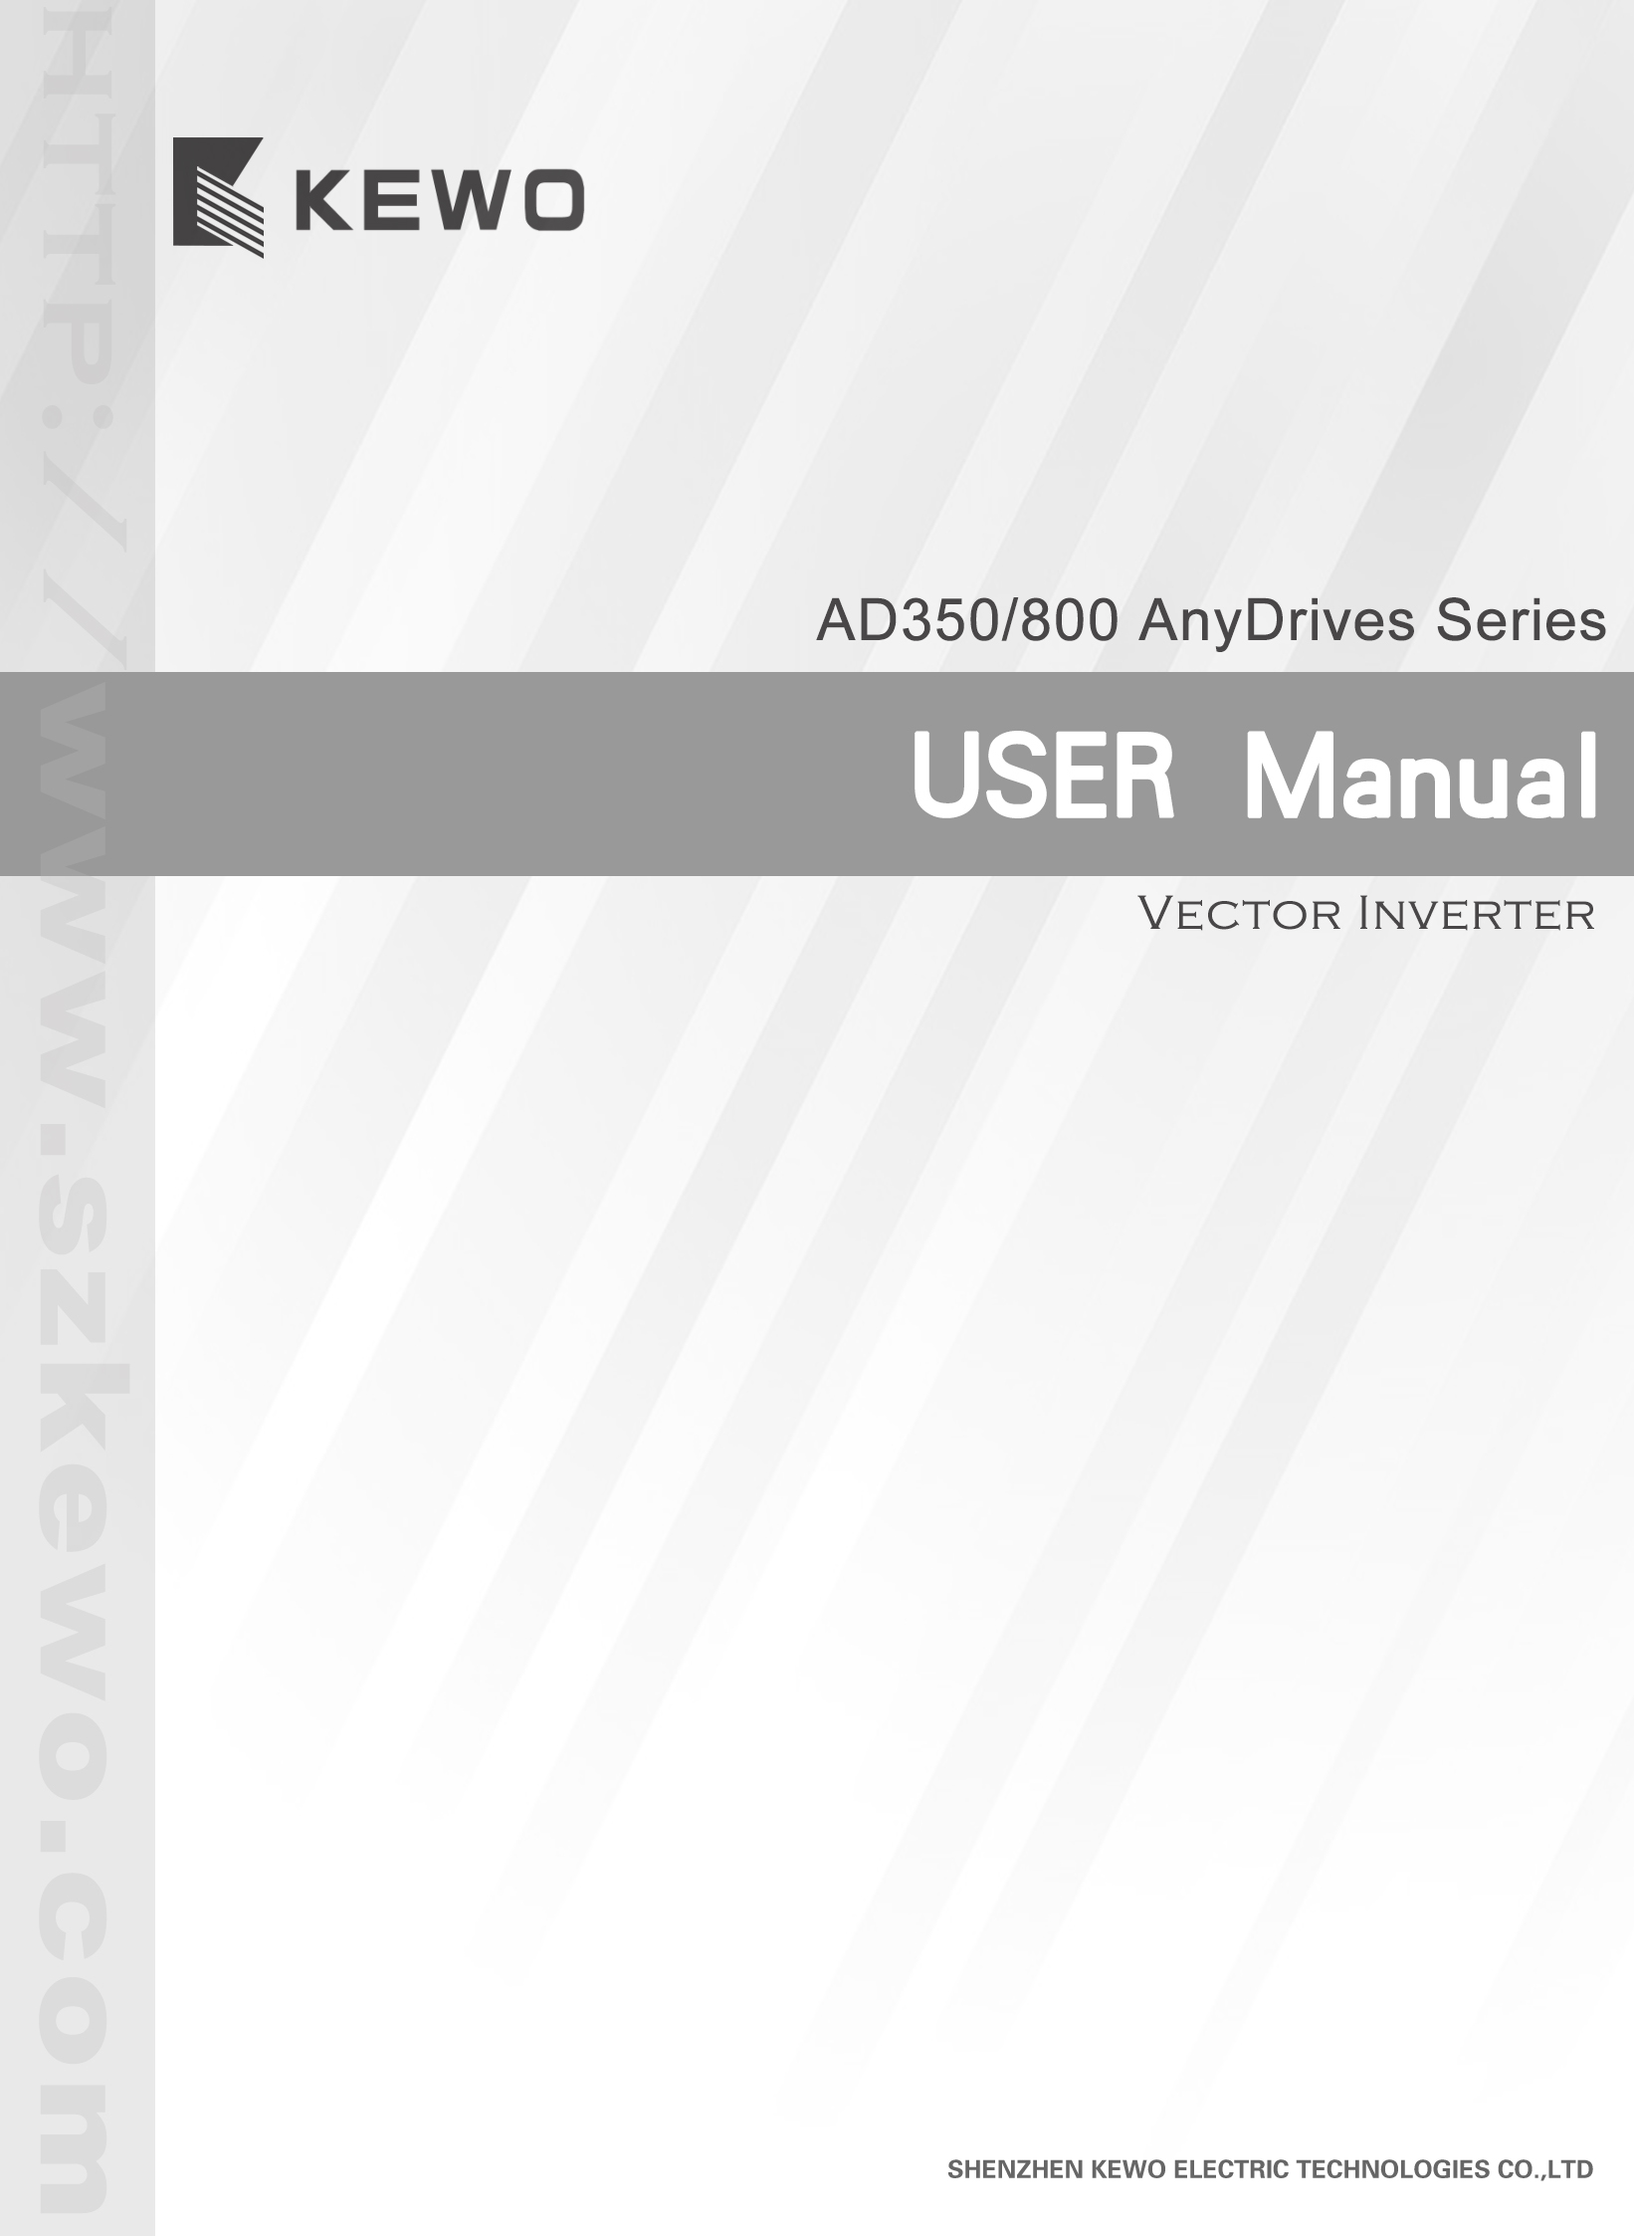

CONTENTS
Chapter 1 product information…………………………………………………1
Chapter 2 Installation and connection…………………………………………2
2.1 Wiring of the main circuit……………………………………… 3
2.2 Can out keying and installation size………………………………4
2.3 Description of control circuit terminals……………………………4
2.4 Description of control circuit terminals…………………………6
Chapter 3 Function code table………………………………………………8
P0 Standard function parameters…………………………………8
P1 Start/stop control…………………………………………10
P2 Motor parmerters……………………………………………11
P3 Vector contro…………………………………………………12
P4 V/Fcontrol parmeters…………………………………………13
P5 Input teminals……………………………………………14
P6 Output teminals………………………………………………18
P7 Operation panel and display……………………………………20
P8 Auxiliary functions……………………………………………23
P9 PID function…………………………………………………28
PA Multi-Reference and Simple PLC Function………………………30
Pb Swing Frequency, Fixed Length and Count………………………34
PC Fault and protection…………………………………………35
Pd Communication Parameters……………………………………38
H0 Torque Control and Restricting Parameters………………………39
H7 AIAO correction………………………………………………40
C0 Standard Monitoring Parameters………………………………42
Chapter 4 Maintenance and Troubleshooting…………………………………42

Chapter 1 product information

1.1 Designation rules
AD350－4 T 1.5G B
1.5KW
mark
0.75 1.5 2.2 ...
adaptable motor
0.75 1.5 2.2 ...
series AC drive
B
braking unit yes 一yes
blank
no
voltage
220V
380V
4
2

mark
single-phase
three-phase
T
S

1.2 Nameplate of the AD800/350

KEWO INVERTER
MODEL: | AD350－4T1.5G
INPUT: | AC 3PH 380V＋15% 50/60Hz
OUTPUT: | AC 3PH 0~380V 0~400Hz 3.8A
NO:
SHENZHEN KEWO ELECTRIC TECHNOLOGIES CO.,LTD

AC drive model
Rated inpwt
Rated output
Manufacturing no

Chapter 2 Installation

2.1 wiring of AC Drive main circuit
2.1.1 single-phase
For：AD350-2S0.4G～2S2.2G
P+ PB R T U V W
power

motor

Description

Braking resistor
Braking resistor | Name | Description
R T | Single--phase power supply inoute terminals | Connect to the single--phase 220V AC power supply
U V W | AC drive ortput terminals | Connect to a three--phase motor
P+ PB | Connecting terminals of braking resistor | Connect to a braking resistor
 | Grounding terminal | Must be grounded

2.1.2 three-phase A
For：AD350-2T0.4G～2T2.2G/AD350-4T0.75G～4T3.7G
P+ PB R S T U V W

motor
power

Description
Braking resistor
Braking resistor | Name | Description
R S T | Three--phase power supply inoute terminals | Connect to the three--phase AC power supply
U V W | AC drive ortput terminals | Connect to a three--phase motor
P+ PB | Connecting terminals of braking resistor | Connect to a braking resistor
 | Grounding terminal | Must be grounded

.1.3 three-phase B
For：AD800-4T0.75G～4T55G

Braking resistor
P+ P- R S T U V W PB

motor
power

Description

Braking resistor | Name | Description
R S T | Single--phase power supply inoute terminals | Connect to the single--phase 380V AC power supply
U V W | AC drive ortput terminals | Connect to a three--phase motor
P+ PB | Connecting terminals of braking resistor | Connect to a braking resistor
P+ P－ | Positive and negatiue terminals of Dc bus | Common Dc bus input point
 | Grounding terminal | Must be grounded

2.2 Can out keying and installation size
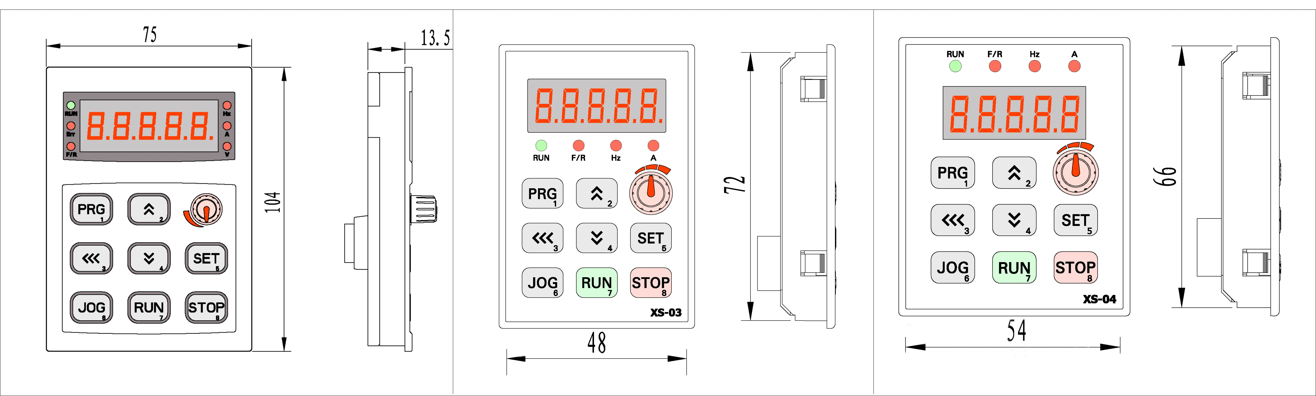

XS-01 ★ XS-03 XS-04

2.3 Description of control circuit terminals
2.3.1 AD350 terminal arrangement of control circuit

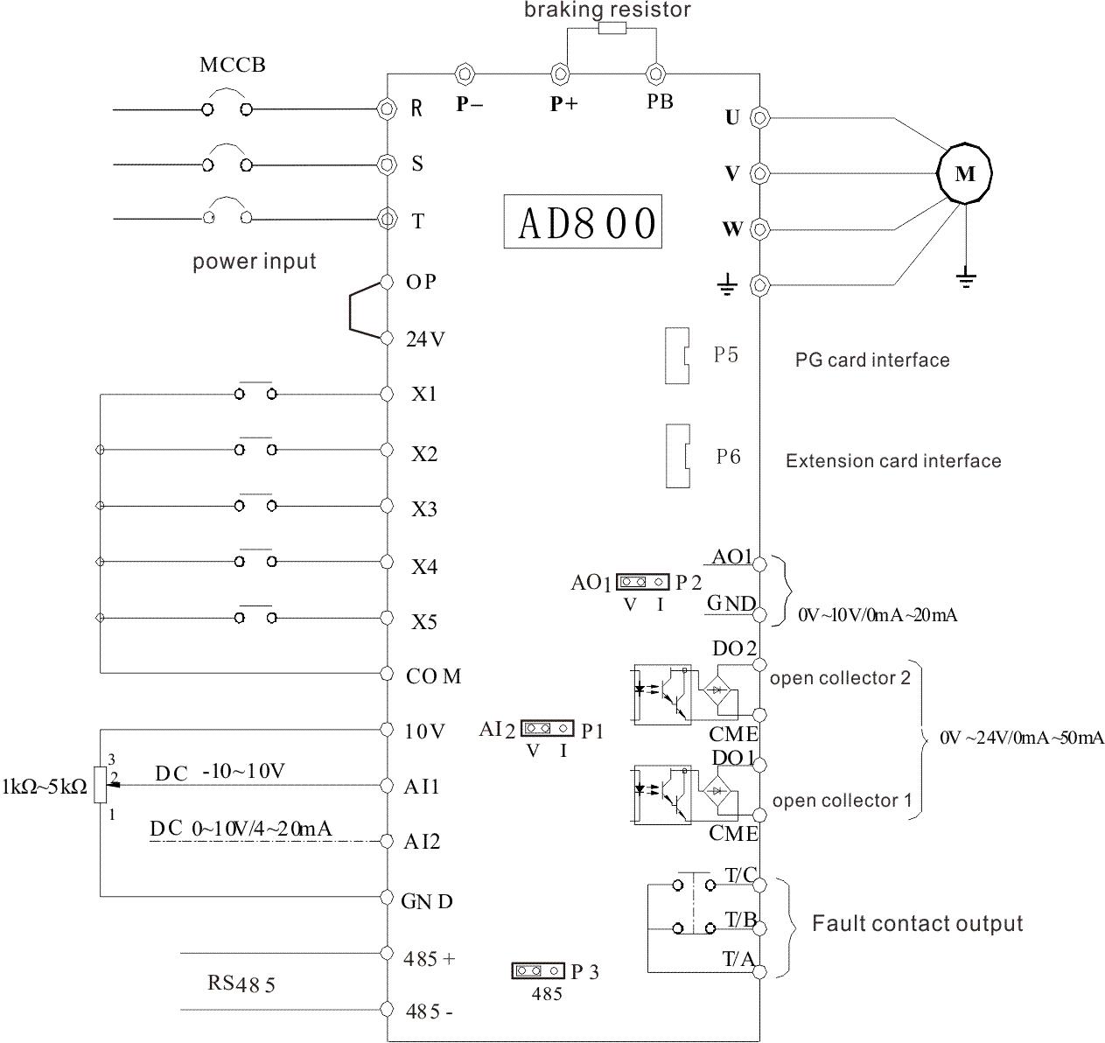

2.3.2 AD800 terminal arrangement of contrd circuit

2.4 Description of control circuit terminals（AD350、AD800）：
Terrminal | Name | Function Description
X1 COM | Digtal input 1 | 1.Optical coupling isolation, compatible with dual polarity input  2.Impedance: 2.4 kΩ  3.Voltage range for level input: 9–30 V
X2 COM | Digtal input 2
X3 COM | Digtal input 3
X4 COM | Digtal input 4
X5 COM | Digtal input 5  High-speed pluse | Besides features of X1–X4, it can be used for  high-speed pulse input.  Maximum input frequency: 100 kHz
10V GND | External +10 V  power supply | Provide +10 V power supply to external unit. Generally, it provides power supply to external  potentiometer with resistance range of 1–5 kΩ.  Maximum output current: 10 mA
24V COM | External  +24V power  supplyApplying to Overvoltage  Category II circuit | Provide +24V power supply to external unit.  Generally, it provides power supply to X/DO terminals  and external sensors.  Maximum output current: 200 mA
OP | Input terminal of  external power  supply | Connect to +24 V by default.  When X1-X5 need to be driven by external signal, OP  needs to be connected to external power supply and be disconnected from +24 V
AI1 GND | Analog input 1 | Input voltage range: 0~10 VDC  Impedance: 22 kΩ
AI2 GND | Analog input 2 | Input range: 0~10 VDC/4~20 mA, decided by jumper P1 on the control board  Impedance: 22 kΩ (voltage input), 500 Ω (currentinput)
AO1 GND | Analog output 1 | Voltage or current output is decided by jumper P2  Output voltage range: 0–10 V Output current range: 0–20 mA
DO1 CME | Digital output 1 | Optical coupling isolation, dual polarity open collector output  Output voltage range: 0–24 V Output current range: 0–50 mA  Note that CME and COM are internally insulated, but they are shorted by jumper externally. In this case DO1 is driven by  +24 V by default. If you want to drive DO1 by external power supply, remove the jumper.
FM COM | High-speed pulse output | is limited by F5-00 (FM terminal output modeselection).  As high-speed pulse output, the maximum frequency hits 100 kHz.  As open-collector output, its specification is the  same as that of DO1
TA TB TC | TA-TC NO terminal  TA-TB NC terminal | Contact driving capacity: 250 VAC, 3 A, COSø = 0.4  30 VDC, 1 A  Applying to Overvoltage Category II circuit
485+ 485- | 485 communication
P3 | PG card interface | Support various types of PG cards: OC, and resolver.
P4 | Extension card interface | Connect to an optional card (I/O extension card, card and various bus cards)

Chapter 3 Function code table
FunctionCode | Name | Setting range | Default | Property

P0 Standard function parameters
P0.00 | control mode | 0: Sensorless flux vector control  1: Voltage/Frequency (V/F) control  2: Closed-loop vector control | 0 | ★
P0.01 | Command source selection | 0: Operation panel control  1: Terminal control  2: Communication control | 0 | ☆
P0.02 | Retentive of digital setting frequency upon power failure | 0: Not retentive  1: Retentive | 1 | ☆
P0.03 | Main frequency source X selection | 0: Digital setting (non-retentive at power failure)  1: Digital setting (retentive at power failure)  2: AI1  3: AI2  4: Keying potentiomcter  5: Pulse setting (X5)  6: Multi-reference  7: Simple PLC  8: PID  9: Communication setting | 0 | ★
P0.04 | Maximum frequency | 50.00–400.00 Hz | 50.00Hz | ★
P0.05 | Frequency upper limit | P0.06～P0.04 | 50.00Hz | ☆
P0.06 | Frequency lower limit | 0.00Hz～P0.05 | 0.00Hz | ☆
P0.07 | Preset frequency | 0.00Hz～P0.04 | 50.00Hz | ☆
P0.08 | Acceleration time 1 | 0.00s～65000s | Model dependen | ☆
P0.09 | Deceleration time 1 | 0.00s～65000s | Model dependen | ☆
P0.10 | Rotation direction | 0: Same direction  1: Reverse direction | 0 | ☆
P0.11 | Carrier frequency | 0.5kHz～16.0kHz | Model dependen | ☆
P0.12 | Carrier frequency adjustment with temperature | 0: No  1: Yes | 1 | ☆
P0.13 | Restore default settings | 0: No operation  01: Restore factory settings except motor parameters  02: Clear records | 0 | ★
P0.14 | Auxiliary frequency source selection | The same as p0.03 (Main  frequency source X selection) | 0 | ★
P0.15 | Range of auxiliary frequency for and operation | 0: Relative to maximum frequency 1: Relative to main frequency | 0 | ☆
P0.16 | Range of auxiliary frequency for and operation | 0%～150% | 100% | ☆
P0.17 | Frequency source selection | 0: Main frequency source X  1: X and Y operation  (operation relationship determined by ten's digit)  2: Switchover between X and Y  3: Switchover between X and "X  and Y operation" | 00 | ☆
P0.18 | Terminal command mode | 0: Two-line mode 1  1: Two-line mode 2  2: Three-line mode 1  3: Three-line mode 2 | 0 | ★
P1 Start/stop control |  |  |  |  |  | 0: X+Y  1: X-Y  2: Maximum  3: Minimum
P1.00 | Start mode | 0: Direct start  1: Rotational speed tracking restart  2: Pre-excited start | 0 | ☆
P1.01 | Startup frequency | 0.00Hz～10.00Hz | 0.00Hz | ☆
P1.02 | Startup frequency holding time | 0.0s～100.0s | 0.0s | ★
P1.03 | Startup DC braking current | 0%～100% | 0% | ★
P1.04 | Startup DC braking time | 0.0s～100.0s | 0.0s | ★
P1.05 | Stop mode | 0: Decelerate to stop 1: Coast to stop | 0 | ☆
P1.06 | Initial frequency of stop DC braking | 0.00Hz～P0.04 | 0.00Hz | ☆
P1.07 | Waiting time of stop DC braking | 0.0s～100.0s | 0.0s | ☆
P1.08 | Stop DC braking current | 0%～100% | 0% | ☆
P1.09 | Stop DC braking time | 0.0s～100.0s | 0.0s | ☆
P1.10 | Brake use ratio | 0%～100% | 100% | ☆
P1.11 | Reverse control | 0: Enabled  1: Disabled | 0 | ★
P1.12 | JOG running frequency | 0.00Hz～P0.04 | 5.00Hz | ☆

P2 Motor Parameters
P2.01 | Motor type selection | 0: Common asynchronous motor  1: Variable frequency asynchronous motor | 0 | ★
P2.02 | Rated motor power | 0.1kW～1000.0kW | Model dependent | ★
P2.03 | Rated motor frequency | 0.00Hz～P0.04 | 50.00 | ★
P2.04 | Rated motor rotational speed | 0rpm～65535rpm | 1460rpm | ★
P2.05 | Rated motor voltage | 0V～2000V | 380 | ★
P2.06 | Rated motor current | 0.1A～2000A | Model dependent | ★
P2.07 | Stator resistance (asynchronous motor) | 0.001Ω～65.535Ω | Model dependent | ★
P2.08 | Rotor resistance (asynchronous motor) | 0.001Ω～65.535Ω | Model dependent | ★
P2.09 | Leakage inductive reactance (asynchronous motor) | 0.01mH～655.35mH | Model dependent | ★
P2.10 | Mutual inductive reactance (asynchronous motor) | 0.1mH～6553.5mH | Model dependent | ★
P2.11 | No-load current (asynchronous motor) | 0.01A～P1.03 | Model dependent | ★
P2.18 | Encoder pulses per revolution | 1～65535 | 1024 | ★
P2.19 | Encoder type | 0：ABZ incremental encoder  1：Resolver | 0 | ★
P2.21 | A/B phase sequence of ABZ incremental encoder | 0: Forward  1: Reserve | 0 | ★
P2.25 | Number of pole pairs of resolver | 1～65535 | 1 | ★
P2.27 | Auto-tuning selection | 0: No auto-tuning  1: Asynchronous motor static auto-tuning  2: Asynchronous motor complete auto-tuning | 0 | ★

P3 Vector control
P3.00 | Speed loop proportional gain1 | 1～100 | 30 | ☆
P3.01 | Speed loop integral time 1 | 0.01s～10.00s | 0.50s | ☆
P3.02 | Switchover frequency 1 | 0.00～P3.05 | 5.00Hz | ☆
P3.03 | Speed loop proportional gain2 | 1～100 | 20 | ☆
P3.04 | Speed loop integral time 2 | 0.01s～10.00s | 1.00s | ☆
P3.05 | Switchover frequency 2 | P3.02～P0.04 | 10.00Hz | ☆
P3.06 | Vector control slip gain | 50%～200% | 100% | ☆
P3.07 | Time constant of speed loop filter | 0.000s～0.100s | 0.000s | ☆
P3.08 | Vector control over-  excitation gain | 0～200 | 64 | ☆
P3.09 | Torque upper limit source in speed control mode | 0: P3.10  1: AI1  2: AI2  3: Keying potentiomcter  4: Pulse setting (X5)  5: Communication setting | 0 | ☆
P3.10 | Digital setting of torque upper limit in speed control mode | 0.0%～200.0% | 150.0% | ☆

P4 V/F control parameters
P4.00 | V/F curve setting | 0: Linear V/F  1: Multi-point V/F  2: Square V/F  3: V/F complete separation  4: V/F half separation | 0 | ★
P4.01 | orque boost | 0.0%：（fixed torque boost）  0.1%～30.0% | 0.0% | ☆
P4.02 | Cut-off frequency of torque boost | 0.00Hz～P0.04 | 50.00Hz | ★
P4.03 | V/F slip compensation gain | 0.0%～200.0% | 0.0% | ☆
P4.04 | V/F over-excitation gain | 0～200 | 64 | ☆
P4.05 | Multi-point V/F frequency 1 (F1) | 0.00Hz～P4.07 | 0.00Hz | ★
P4.06 | Multi-point V/F voltage 1 (V1) | 0.0%～100.0% | 0.0% | ★
P4.07 | Multi-point V/F frequency 2 (F2) | P4.06～P4.09 | 0.00Hz | ★
P4.08 | Multi-point V/F voltage 2 (V2) | 0.0%～100.0% | 0.0% | ★
P4.09 | Multi-point V/F frequency 3 (F3) | P4.08～P2.03 | 0.00Hz | ★
P4.10 | Multi-point V/F voltage 3 (V3) | 0.0%～100.0% | 0.0% | ★
P4.11 | Voltage source for V/F separation | 0: Digital setting  1: AI1  2: AI2  3: Keying potentiomcter  4: Pulse setting (X5)  5: Multi-reference | 0 | ☆
P4.12 | Voltage digital setting for V/  F separation | 0V～P2.05 | 0V | ☆
P4.13 | Voltage rise time of V/F separation | 0.0s～1000.0s | 0.0s | ☆

P5 Input Terminals
P5.00 | X1 function selection | 0：No function  1：Forward RUN（FWD）  2：Reverse RUN（REV）  3：Three-line control  4：Forward JOG（FJOG）  5：Reverse JOG（RJOG）  6：Coast to stop  7：Fault reset（RESET）  8：Normally open (NO) input of external fault  9：Terminal UP | 1 | ★
P5.01 | X2 function selection | 10：Terminal DOWN  11： UP and DOWN setting clear (terminal, operation panel)  12：Multi-reference terminal 1  13：Multi-reference terminal 2  14：Multi-reference terminal 3  15：Multi-reference terminal 4  16：Terminal 1 for acceleration/ deceleration time selection  17：Terminal 2 for acceleration/ deceleration time selection  18： Normally closed (NC) input of external fault  19: External STOP terminal 1  20： Frequency source switchover  23： Switchover between auxiliary frequency source and preset frequency  24: Command source switchover terminal 1  25：PID pause  26：Reverse PID action direction  27：PID integral pause  28：PID parameter switchover  29：Counter input  30：Counter reset  31：Length count input  32：Length reset  33：Time function enabled | 2 | ★
P5.02 | X3 function selection |  | 4 | ★
P5.03 | X4 function selection | 34： Swing pause  35： Reserved  36： Acceleration/Deceleration prohibited  37： Immediate DC braking  38： Command source switchover  terminal 2  39：Frequency modification  forbidde  40：Motor selection terminal 1  41：Speed control/Torque control switchover  42： RUN pause  43：User-defined fault 1 | 12 | ★
P5.04 | X5 function selection | 44：User-defined fault 2  46：Torque control prohibited  47：Emergency stop  48：External STOP terminal 2  49：Deceleration DC braking  50：Clear the current running time | 13 | ★
P5.10 | X filter time | 0.000s～1.000s | 0.010s | ☆
P5.11 | AI curve 1 minimum input | -10.00V～P5.13 | 0.20V | ☆
P5.12 | Corresponding setting of AI curve 1 minimum input | -100.0%～+100.0% | 0.0% | ☆
P5.13 | AI curve 1 maximum input | P5.11～+10.00V | 10.00V | ☆
P5.14 | Corresponding setting of AI curve 1 maximum input | -100.0%～+100.0% | 100.0% | ☆
P5.15 | AI1 filter time | 0.00s～10.00s | 0.10s | ☆
P5.16 | AI curve 2 minimum input | 0.00V～P5.18 | 0.20V | ☆
P5.17 | Corresponding setting of AI curve 2 minimum input | -100.0%～+100.0% | 0.0% | ☆
P5.18 | AI curve 2 maximum input | P5.16～+10.00V | 10.00V | ☆
P5.19 | Corresponding setting of AI curve 2 maximum input | -100.0%～+100.0% | 100.0% | ☆
P5.20 | AI2 filter time | 0.00s～10.00s | 0.10s | ☆
P5.26 | Pulse minimum input | 0.00kHz～P5.28 | 0.00kHz | ☆
P5.27 | Corresponding setting of pulse minimum input | -100.0%～100.0% | 0.0% | ☆
P5.28 | Pulse maximum input | P5.26～100.00kHz | 50.00kHz | ☆
P5.29 | Corresponding setting of pulse maximum input | -100.0%～100.0% | 100.0% | ☆
P5.30 | Pulse filter time | 0.00s～10.00s | 0.10s | ☆
P5.32 | Setting for AI less than minimum input | Unit's digit (Setting for AI1 less than minimum input)  0: Minimum value  1: 0.0% | 000 | ☆
P5.33 | X1 delay time | 0.0~3600S | 0.0s | ★
P5.34 | X2 delay time | 0.0~3600S | 0.0s | ★
P5.35 | X3 delay time | 0.0~3600S | 0.0s | ★
P5.36 | x valid mode selection 1 |  | 00000 | ★
P5.37 | x valid mode selection 2 |  | 00000

P6 Output Terminals
P6.00 | FM terminal output mode | 0: Pulse output (FMP)  1: Switch signal output (FMR) | 0 | ☆
P6.01 | FMR function (open- collector output terminal) | 0： No output  1： AC drive running  2： Frequency reached  3： Fault output (stop)  4： Frequency-level detection FDT1 output  5： Frequency level detection FDT2 output  6：Zero-speed running 1(no output  at stop)  7： Zero-speed running 2 (no output  at stoP)  8： Frequency upper limit reached  9： Frequency lower limit reached  10：Frequency 1 reached  11：Frequency 2 reached  12：Accumulative power-on time reached  13：Current running time reached  14：Timing reached  15：Set count value reached  16：Designated count value reached  17：Length reached  18：Undervoltage state output  19：Motor overload pre-warning  20：AC drive overload pre-warning  21：Frequency limited  22：Torque limited  23：AI1>AI2  25：AI1 input limit exceeded  26：Zero-speed running 2 (having  output at stop) | 0 | ☆
P6.02 | Relay function (T/A-T/B-T/C) |  | 3 | ☆
P6.03 | Extension card relay function |  | 0 | ☆
P6.04 | DO1 function selection (open- collector output terminal) |  | 1 | ☆
P6.05 | Extension card DO2 function |  | 4 | ☆
P6.06 | FMP function selection | 0： Running frequency  1： Set frequency  2： Output current  3：Output torque (absolute value)  4：Output power  5：Output voltage  6：Pulse input  7：AI1  8：AI2  9：Keying potentiomcter  10：Length  11： Count value  12：Communication setting  13：Motor rotational speed  14：Output current  15：Output voltage  16：Output torque | 0 | ☆
P6.07 | AO1 function selection |  | 0 | ☆
P6.08 | AO2 function selection |  | 1 | ☆
P6.09 | Maximum FMP output frequency | 0.01kHz～100.00kHz | 50.00kHz | ☆
P6.10 | AO1 offset coefficient | -100.0%～100.0% | 0.0% | ☆
P6.11 | AO1 gain | -10.00～10.00 | 1.00 | ☆
P6.12 | AO2 offset coefficient | -100.0%～100.0% | 0.0% | ☆
P6.13 | AO2 gain | -10.00～10.00 | 1.00 | ☆
P6.14 | FMR output delay time | 0.0s～3600.0s | 0.0s | ☆
P6.15 | Relay 1 output delay time | 0.0s～3600.0s | 0.0s | ☆
P6.16 | Relay 2 output delay time | 0.0s～3600.0s | 0.0s | ☆
P6.17 | DO1 output delay time | 0.0s～3600.0s | 0.0s | ☆
P6.18 | DO2 output delay time | 0.0s～3600.0s | 0.0s | ☆
P6.19 | DO valid mode selection |  | 00000 | ☆

P7 Operation Panel and Display
P7.00 | Restore default settings | 0～65535 | 0 | ☆
P7.01 | AC drive parameter display property | Unit's digit (Group c display selection)  0: Not display  1: Display  Ten's digit (Group A display selection) | 00 | ☆
P7.03 | Parameter modification property | 0: Modifiable  1: Not modifiable | 0 | ☆
P7.04 | JOG Key function selection | 0: JOG key disabled  1: Switchover between operation panel control and remote command control (terminal or communication)  2: Switchover between forward rotation and reverse rotation  3: Forward JOG  4: Reverse JOG | 3 | ★
P7.05 | STOP/RESET key function | 0: STOP/RESET key enabled only in operation panel control  1: STOP/RESET key enabled in anyoperation mode | 1 | ☆
P7.06 | LED display running parameters 1 | 0000–FFFF  Bit00: Running frequency 1 (Hz)  Bit01: Set frequency (Hz)  Bit02: Bus voltage (V)  Bit03: Output voltage (V)  Bit04: Output current (A)  Bit05: Output power (kW)  Bit06: Output torque (%)  Bit07: DI input status | 33 | ☆
P7.07 | LED display running parameters 2 | Bit08: DO output status  Bit09: AI1 voltage (V)  Bit10: AI2 voltage (V)  Bit11: Keying potentiomcter (V)  Bit12: Count value  Bit13: Length value  Bit14: Load speed display  Bit15: PID setting | 0 | ☆
P7.08 | LED display stop parameters | 0000–FFFF  Bit00: Set frequency (Hz)  Bit01: Bus voltage (V)  Bit02: DI input status  Bit03: DO output status  Bit04: AI1 voltage (V)  Bit05: AI2 voltage (V)  Bit06: AI3 voltage (V)  Bit07: Count value  Bit08: Length value  Bit09: PLC stage  Bit10: Load speed  Bit11: PID setting  Bit12: Pulse setting frequency  (kHz) | 3 | ☆
P7.09 | Load speed display coefficient | 0.0001～6.5000 | 1.0000 | ●
P7.10 | Heatsink temperature of inverter module | 0.0℃～100℃ | - | ●
P7.12 | Accumulative running time | 0h～65535h | - | ●
P7.15 | Number of decimal places for load speed display | 0: 0 decimal place  1: 1 decimal place  2: 2 decimal places  3: 3 decimal places | - | ●
P7.16 | Accumulative power-on time | 00000～65535h | - | ●

P8 Auxiliary Functions
P8.00 | Acceleration/Deceleration time unit | 0:1s  1: 0.1s  2: 0.01s | 1 | ★
P8.01 | JOG acceleration time | 0.0s～6500.0s | 20.0s | ☆
P8.02 | JOG deceleration time | 0.0s～6500.0s | 20.0s | ☆
P8.03 | Acceleration time 2 | 0.0s～6500.0s | 20.0s | ☆
P8.04 | Deceleration time 2 | 0.0s～6500.0s | 20.0s | ☆
P8.05 | Acceleration time 3 | 0.0s～6500.0s | 20.0s | ☆
P8.06 | Deceleration time 3 | 0.0s～6500.0s | 20.0s | ☆
P8.07 | Acceleration time 4 | 0.0s～6500.0s | 20.0s | ☆
P8.08 | Deceleration time 4 | 0.0s～6500.0s | 20.0s | ☆
P8.10 | Acceleration/Deceleration time base frequency | 0: Maximum frequency (p0.04)  1: Set frequency  2: 100 Hz | 0 | ★
P8.11 | Jump frequency 1 | 0.00Hz～P0.04 | 0.00Hz | ☆
P8.12 | Jump frequency 2 | 0.00Hz～P0.04 | 0.00Hz | ☆
P8.13 | Frequency jump amplitude | 0.00Hz～P0.04 | 0.01Hz | ☆
P8.14 | Jump frequency during acceleration/deceleration | 0: Disabled1: Enabled | 0 | ☆
P8.15 | Frequency switchover point between acceleration time 1 and acceleration time 2 | 0.00Hz～P0.04 | 0.00Hz | ☆
P8.16 | Frequency switchover point between deceleration time 1 and deceleration time 2 | 0.00Hz～P0.04 | 0.00Hz | ☆
P8.17 | Terminal JOG preferred | 0: Disabled 1: Enabled | 0 | ☆
P8.18 | Source of frequency upper limit | 0: Set by P0.04  1: AI1  2: AI2  3: Keying potentiomcter  4: Pulse setting (X5)  5: Communication setting | 0 | ★
P8.19 | Frequency upper limit | 0.00Hz～P0.04 | 0.00Hz | ☆
P8.20 | Frequency offset of auxiliary frequency source for X and Y operation | 0.00Hz～P0.04 | 0.00Hz | ☆
P8.21 | Base frequency for UP/ DOWN modification during running | 0: Running frequency  1: Set frequency | 0 | ★
P8.22 | Binding command source to frequency source | Unit's digit (Binding operation panel command to frequency source)  0: No binding  1: Frequency source by digital setting  2: AI1  3: AI2  4: Keying potentiomcter  5: Pulse setting (X5)  6: Multi-reference  7: Simple PLC  8: PID  9: Communication setting | 0000 | ☆
P8.24 | Acceleration/Deceleration mode | 0: Linear acceleration/ deceleration  1: S-curve acceleration/ deceleration | 0 | ★
P8.25 | Time proportion of S-curve start segment | 0.0%～(100.0%-P8.26) | 30.0% | ★
P8.26 | Time proportion of S-curve end segment | 0.0%～(100.0%-P8.25) | 30.0% | ★
P8.27 | Forward/Reverse rotation dead-zone time | 0.0s～3000.0s | 0.0s | ☆
P8.29 | Running mode when set frequency lower than frequency lower limit | 0: Run at frequency lower limit  1: Stop  2: Run at zero speed | 0 | ☆
P8.30 | Startup protection | 0: No 1: Yes | 0 | ☆
P8.31 | Droop control | 0.00Hz～10.00Hz | 0.00Hz | ☆
P8.32 | Frequency detection value (FDT1) | 0.00Hz～P0.04 | 50.00Hz | ☆
P8.33 | Frequency detection hysteresis (FDT hysteresis 1) | 0.0%～100.0% | 5.0% | ☆
P8.34 | Detection range of frequency reached | 0.0%～100.0%（P0.04） | 0.0% | ☆
P8.35 | Frequency detection value (FDT2) | 0.00Hz～P0.04 | 50.00Hz | ☆
P8.36 | Frequency detection hysteresis (FDT hysteresis 2) | 0.0%～100.0% | 5.0% | ☆
P8.37 | Any frequency reaching detection value 1 | 0.00Hz～P0.04 | 50.00Hz | ☆
P8.38 | Any frequency reaching detection amplitude 1 | 0.0%～100.0%（P0.04） | 0.0% | ☆
P8.39 | Any frequency reaching detection value 2 | 0.00Hz～P0.04 | 50.00Hz | ☆
P8.40 | Any frequency reaching detection amplitude 2 | 0.0%～100.0%（P0.04） | 0.0% | ☆
P8.42 | Timing duration source | 0: P8.43  1: AI1  2: AI2  3: Keying potentiomcter  (100% of analog input corresponds  to the value of P8.43) | 0 | ☆
P8.43 | Timing duration | 0.0Min～6500.0Min | 0.0Min | ☆
P8.44 | Zero current detection level | 0.0%–300.0% (rated motor current) | 5.0% | ☆
P8.45 | Zero current detection delay time | 0.01s～600.00s | 0.10s | ☆
P8.46 | Output overcurrent threshold | 0.0% (no detection)  0.1%–300.0% (rated motor current) | 200.0% | ☆
P8.47 | Output overcurrent detection delay time | 0.00s～600.00s | 0.00s | ☆
P8.48 | Any current reaching 1 | 0.0%～300.0%(rated motor current) | 100.0% | ☆
P8.49 | Any current reaching 1 amplitude | 0.0%～300.0%(rated motor current) | 0.0% | ☆
P8.50 | Any current reaching 2 | 0.0%～300.0%(rated motor current) | 100.0% | ☆
P8.51 | Any current reaching2 amplitude | 0.0%～300.0%(rated motor current) | 0.0% | ☆
P8.52 | AI1 input voltage lower limit | 0.00V～P8.53 | 3.00V | ☆
P8.53 | AI1 input voltage upper limit | P8.52～11.00V | 7.00V | ☆
P8.54 | Cooling fan control | 0: Fan working during running  1: Fan working continuously | 0 | ☆
P8.55 | Module temperature threshold | 0℃～100℃ | 75℃ | ☆
P8.56 | Current running time reached | 0.0Min～6500.0Min | 0.0Min | ☆

P9 PID PID Function
P9.00 | PID setting source | 0: P9.01  1: AI1  2: AI2  3: Keying potentiomcter  4: Pulse setting (X5)  5: Communication setting | 0 | ☆
P9.01 | PID digital setting | 0.0%～100.0% | 50.0% | ☆
P9.02 | PID feedback source | 0: AI1  1: AI2  2: Retain  3: AI1 – AI2  4: Pulse setting (X5)  5: Communication setting  6: AI1 + AI2  7: MAX (|AI1|, |AI2|)  8: MIN (|AI1|, |AI2|) | 0 | ☆
P9.03 | PID action direction | 0: Forward action  1: Reverse action | 0 | ☆
P9.04 | PID setting feedback range | 0～65535 | 1000 | ☆
P9.05 | Proportional gain Kp1 | 0.0～100.0 | 20.0 | ☆
P9.06 | Integral time Ti1 | 0.01s～10.00s | 2.00s | ☆
P9.07 | Differential time Td1 | 0.000s～10.000s | 0.000s | ☆
P9.08 | Cut-off frequency of PID reverse rotation | 0.00～P0.04 | 2.00HZ | ☆
P9.09 | PID deviation limit | 0.0%～100.0% | 0.0% | ☆
P9.10 | PID differential limit | 0.00%～100.00% | 0.10% | ☆
P9.11 | PID setting change time | 0.00～650.00s | 0.00s | ☆
P9.12 | PID feedback filter time | 0.00～60.00s | 0.00s | ☆
P9.13 | PID output filter time | 0.00～60.00s | 0.00s | ☆
P9.15 | Proportional gain Kp2 | 0.0～100.0 | 20.0 | ☆
P9.16 | ntegral time Ti2 | 0.01s～10.00s | 2.00s | ☆
P9.17 | Differential time Td2 | 0.000s～10.000s | 0.000s | ☆
P9.18 | PID parameter switchover condition | 0: No switchover  1: Switchover via X  2: Automatic switchover based on deviation | 0 | ☆
P9.19 | PID parameter switchover deviation 1 | 0.0%～P9.20 | 20.0% | ☆
P9.20 | PID parameter switchover deviation 2 | P9.19～100.0% | 80.0% | ☆
P9.21 | PID initial value | 0.0%～100.0% | 0.0% | ☆
P9.22 | PID initial value holding time | 0.00～650.00s | 0.00s | ☆
P9.23 | Maximum deviation between two PID outputs in forward direction | 0.00%～100.00% | 1.00% | ☆
P9.24 | Maximum deviation between two PID outputs in reverse direction | 0.00%～100.00% | 1.00% | ☆
P9.25 | PID integral property | 0: Invalid  1: Valid | 00 | ☆
P9.26 | Detection value of PID feedback loss | 0.0%: Not judging feedback loss 0.1%–100.0% | 20.0% | ☆
P9.27 | Detection time of PID feedback loss | 0.0s～20.0s | 1.0s | ☆
P9.28 | PID operation at stop | 0: No PID operation at stop  1: PID operation at stop | 0 | ☆
P9.29 | Wakeup frequency | Dormant frequency (P9.31) to maximum frequency (P0.04) | 0.00Hz | ☆
P9.30 | Wakeup delay time | 0.0s～6500.0s | 0.0s | ☆
P9.31 | Dormant frequency | 0.00Hz～Wakeup frequency（P9.29) | 0.00Hz | ☆
P9.32 | Dormant delay time | 0.0s～6500.0s | 0.0s | ☆

PA Multi-Reference and Simple PLC Function
PA.00 | Reference 1 | -100.0%–100.0% | 5.0% | ☆
PA.01 | Reference 2 | -100.0%～100.0% | 10.0% | ☆
PA.02 | Reference 3 | -100.0%～100.0% | 15.0% | ☆
PA.03 | Reference 4 | -100.0%～100.0% | 20.0% | ☆
PA.04 | Reference 5 | -100.0%～100.0% | 25.0% | ☆
PA.05 | Reference 6 | -100.0%～100.0% | 30.0% | ☆
PA.06 | Reference 7 | -100.0%～100.0% | 35.0% | ☆
PA.07 | Reference 8 | -100.0%～100.0% | 40.0% | ☆
PA.08 | Reference 9 | -100.0%～100.0% | 45.0% | ☆
PA.09 | Reference 10 | -100.0%～100.0% | 50.0% | ☆
PA.10 | Reference 11 | -100.0%～100.0% | 55.0% | ☆
PA.11 | Reference 12 | -100.0%～100.0% | 60.0% | ☆
PA.12 | Reference 13 | -100.0%～100.0% | 65.0% | ☆
PA.13 | Reference 14 | -100.0%～100.0% | 70.0% | ☆
PA.14 | Reference 15 | -100.0%～100.0% | 75.0% | ☆
PA.15 | Reference 16 | -100.0%～100.0% | 80.0% | ☆
PA.16 | Simple PLC running mode | 0: Stop after the AC drive runs one cycle  1: Keep final values after the AC  drive runs one cycle  2: Repeat after the AC drive runs one cycle | 0 | ☆
PA.17 | Simple PLC retentive selection | Unit's digit (Retentive upon power failure) | 00 | ☆
PA.18 | Running time of simple PLC reference 1 | 0.0–6553.5s (h) | 0.0s(h) | ☆
PA.19 | Acceleration/deceleration time of simple PLCreference1 | 0～3 | 0 | ☆
PA.20 | Running time of simple PLC reference 2 | 0.0s(h)～6500.0s(h) | 0.0s(h) | ☆
PA.21 | Acceleration/deceleration time of simple PLCreference2 | 0～3 | 0 | ☆
PA.22 | Running time of simple PLC reference 3 | 0.0s(h)～6500.0s(h) | 0.0s(h) | ☆
PA.23 | Acceleration/deceleration time of simple PLCreference3 | 0～3 | 0 | ☆
PA.24 | Running time of simple PLC reference 4 | 0.0s(h)～6500.0s(h) | 0.0s(h) | ☆
PA.25 | Acceleration/deceleration time of simple PLCreference4 | 0～3 | 0 | ☆
PA.26 | Running time of simple PLC reference 5 | 0.0s(h)～6553.5s(h) | 0.0s(h) | ☆
PA.27 | Acceleration/deceleration time of simple PLCreference5 | 0～3 | 0 | ☆
PA.28 | Running time of simple PLC reference 6 | 0.0s(h)～6553.5s(h) | 0.0s(h) | ☆
PA.29 | Acceleration/deceleration time of simple PLCreference6 | 0～3 | 0 | ☆
PA.30 | Running time of simple PLC reference 7 | 0.0s(h)～6553.5s(h) | 0.0s(h) | ☆
PA.31 | Acceleration/deceleration time of simple PLCreference7 | 0～3 | 0 | ☆
PA.32 | Running time of simple PLC reference 8 | 0.0s(h)～6553.5s(h) | 0.0s(h) | ☆
PA.33 | Acceleration/deceleration time of simple PLCreference8 | 0～3 | 0 | ☆
PA.34 | Running time of simple PLC reference 9 | 0.0s(h)～6553.5s(h) | 0.0s(h) | ☆
PA.35 | Acceleration/deceleration time of simple PLCreference9 | 0～3 | 0 | ☆
PA.36 | Running time of simple PLC reference 10 | 0.0s(h)～6553.5s(h) | 0.0s(h) | ☆
PA.37 | Acceleration/deceleration time of simple PLCreference10 | 0～3 | 0 | ☆
PA.38 | Running time of simple PLC reference 11 | 0.0s(h)～6553.5s(h) | 0.0s(h) | ☆
PA.39 | Acceleration/deceleration time of simple PLCreference11 | 0～3 | 0 | ☆
PA.40 | Running time of simple PLC reference 12 | 0.0s(h)～6553.5s(h) | 0.0s(h) | ☆
PA.41 | Acceleration/deceleration time of simple PLCreference12 | 0～3 | 0 | ☆
PA.42 | Running time of simple PLC reference 13 | 0.0s(h)～6553.5s(h) | 0.0s(h) | ☆
PA.43 | Acceleration/deceleration time of simple PLCreference13 | 0～3 | 0 | ☆
PA.44 | Running time of simple PLC reference 14 | 0.0s(h)～6553.5s(h) | 0.0s(h) | ☆
PA.45 | Acceleration/deceleration time of simple PLCreference14 | 0～3 | 0 | ☆
PA.46 | Running time of simple PLC reference 15 | 0.0s(h)～6553.5s(h) | 0.0s(h) | ☆
PA.47 | Acceleration/deceleration time of simple PLCreference15 | 0～3 | 0 | ☆
PA.48 | Running time of simple PLC reference 16 | 0.0s(h)～6553.5s(h) | 0.0s(h) | ☆
PA.49 | Acceleration/deceleration time of simple PLCreference16 | 0～3 | 0 | ☆
PA.50 | Time unit of simple PLC running | 0: s (second)1:h (hour) | 0 | ☆
PA.51 | Reference 139 source | 0: Set by PA.00  1: AI1  2: AI2  3: Keying potentiomcter  4: Pulse setting  5: PID  6: Set by preset frequency (F0- 08), modified via terminal UP/ DOWN | 0 | ☆

Pb Swing Frequency, Fixed Length and Count
Pb.00 | Swing frequency setting mode | 0: Relative to the central frequency  1: Relative to the maximum frequency | 0 | ☆
Pb.01 | Swing frequency amplitude | 0.0%～100.0% | 0.0% | ☆
Pb.02 | Jump frequency amplitude | 0.0%～50.0% | 0.0% | ☆
Pb.03 | Swing frequency cycle | 0.1s～3000.0s | 10.0s | ☆
Pb.04 | Triangular wave rising time coefficient | 0.1%～100.0% | 50.0% | ☆
Pb.05 | Set length | 0m～65535m | 1000m | ☆
Pb.06 | Actual length | 0m～65535m | 0m | ☆
Pb.07 | Number of pulses per meter | 0.1～6553.5 | 100.0 | ☆
Pb.08 | Set count value | 1～65535 | 1000 | ☆
Pb.09 | Designated count value | 1～65535 | 1000 | ☆

PC Fault and Protection
PC.00 | Motor overload protection selection | 0: Disabled  1: Enabled | 1 | ☆
PC.01 | Motor overload protection gain | 0.20～10.00 | 1.00 | ☆
PC.02 | Motor overload warning coefficient | 50%～100% | 80% | ☆
PC.03 | Overvoltage stall gain | 0～100 | 0 | ☆
PC.04 | Overvoltage stall protective voltage | 120%～150% | 130% | ☆
PC.05 | Overcurrent stall gain | 0～100 | 20 | ☆
PC.06 | Overcurrent stall protective current | 100%～200% | 150% | ☆
PC.08 | Fault auto reset times | 0～20 | 0 | ☆
PC.09 | DO action during fault auto reset | 0: Not act  1: Act | 0 | ☆
PC.10 | Time interval of fault auto reset | 0.1s～100.0s | 1.0s | ☆
PC.13 | 1st fault type | 0：No fault  1:Overcurrent during acceleration (E001)  2：Overcurrent during deceleration (E002)  3：Overcurrent at constant speed (E003)  4：Overvoltage during  acceleration(E004)  5：Overvoltage during deceleration  (E005)  6：Overvoltage at constant speed (E006)  7：Reserved  8：Undervoltage (E008)  9：Reserved  10：Power input phase loss (E010) | － | ●
PC.14 | 2nd fault type | 11：Power output phase loss (E011)  12：Short circuit to ground（E012）  13：AC drive hardware fault（E013）  14：AC drive overload (E014)  15：Motor overload (E015)  16：Module overheat (E016)  17：EEPROM read-write fault（E017）  18：External equipment fault (E018)  19：Accumulative running time reached（E019）  20: Accumulative power-on time reached（E020）  21： Current detection fault (E021）  22：Motor overheat（E022） | － | ●
PC.15 | 3rd (latest) fault type | 23：Contactor fault (E023)  24：Communication fault (E024)  25：Encoder/PG card fault（E025）  26：Motor auto-tuning fault (E026)  27：Initial position fault（E027）  28：With-wave current limit fault（E028）  29：Motor over-speed（E029）  30：Too large speed deviation（E030）  31：Reserved  32：（Load becoming 0E032）  33：PID feedback lost during running (E033) | － | ●
PC.16 | Frequency upon 3rd fault | - | － | ●
PC.17 | Current upon 3rd fault | － | － | ●
PC.18 | Bus voltage upon 3rd fault | － | － | ●
PC.19 | X status upon 3rd fault | － | － | ●
PC.20 | Output terminal status upon 3rd fault | － | － | ●
PC.21 | AC drive status upon 3rd fault | － | － | ●
PC.22 | Power-on time upon 3rd fault | － | － | ●
PC.23 | Running time upon 3rd fault | － | － | ●
PC.24 | Frequency upon 2nd fault | － | － | ●
PC.25 | Current upon 2nd fault | － | － | ●
PC.26 | Bus voltage upon 2nd fault | － | － | ●
PC.27 | X status upon 2nd fault | － | － | ●
PC.28 | Output terminal status upon 2nd fault | － | － | ●
PC.29 | Frequency upon 2nd fault | － | － | ●
PC.30 | Power-on time upon 2rd fault | － | － | ●
PC.31 | Running time upon 2rd fault | － | － | ●
PC.32 | Frequency upon 1nd fault | － | － | ●
PC.33 | Current upon 1nd fault | － | － | ●
PC.34 | Bus voltage upon 1nd fault | － | － | ●
PC.35 | X status upon 1nd fault | － | － | ●
PC.36 | Output terminal status upon 1nd fault | － | － | ●
PC.37 | Frequency upon 1nd fault | － | － | ●
PC.38 | Power-on time upon 1rd fault | － | － | ●
PC.39 | Running time upon 1rd fault | － | － | ●

Pd Communication Parameters
Pd.01 | Baud rate | 1：600BPS  2：1200BPS  3：2400BPS  4：4800BPS  5：9600BPS  6：19200BPS  7：38400BPS  8：57600BPS  9：115200BPS | 5 | ☆
Pd.02 | Data format | 0: No check, data format（8.N-2）  1: Even parity check, data format  （8.E-1）  2: Odd Parity check, data format  <8,O,1>  3: No check, data format <8,N,1>  Valid for Modbus | 0 | ☆
Pd.03 | Local address | 0: Broadcast address  1–247 | 1 | ☆
Pd.04 | Response delay | 0ms～20ms | 2 | ☆
Pd.05 | Communication timeout | 0.0(invalid)；0.1s～60.0s | 0.0 | ☆
Pd.06 | Modbus data forma | 0: Non-standard Modbus protocol  1: Standard Modbus protocol | 1 | ☆

H0 Torque Control and Restricting Parameters
H0.00 | Speed/Torque control selection | 0: Speed control  1: Torque control | 0 | ★
H0.01 | Torque setting source in torque control | 0: Digital setting (H0.03)  1: AI1  2: AI2  3: Keying potentiomcter  4: Pulse setting (X5)  5: Communication setting  6: MIN (AI1, AI2)  7: MAX (AI1, AI2)  Full range of values 1–7  corresponds to the digital setting of H0.03. | 0 | ★
H0.03 | Torque digital setting in torque contro | -200.0%～200.0% | 150.0% | ☆
H0.05 | Forward maximum frequency in torque control | 0.00Hz～P0.04 | 50.00Hz | ☆
H0.06 | Reverse maximum frequency in torque control | 0.00Hz～P0.04 | 50.00Hz | ☆
H0.07 | Acceleration time in torque control | 0.00s～65000s | 0.00s | ☆
H0.08 | Deceleration time in torque control | 0.00s～65000s | 0.00s | ☆

H7 AI/AO Correction
H7.00 | AI1 measured voltage 1 | -9.999V～10.000V | Factory corrected | ☆
H7.01 | AI1 displayed voltage 1 | -9.999V～10.000V | Factory corrected | ☆
H7.02 | AI1 measured voltage 2 | -9.999V～10.000V | Factory corrected | ☆
H7.03 | AI1 displayed voltage 2 | -9.999V～10.000V | Factory corrected | ☆
H7.04 | AI2 measured voltage 1 | 0.500V～4.000V | Factory corrected | ☆
H7.05 | AI2 displayed voltage 1 | 0.500V～4.000V | Factory corrected | ☆
H7.06 | AI2 measured voltage 2 | 6.000V～9.999V | Factory corrected | ☆
H7.07 | AI2 displayed voltage 2 | 6.000V～9.999V | Factory corrected | ☆
H7.12 | AO1 target voltage 1 | 0.500V～4.000V | Factory corrected | ☆
H7.13 | AO1 measured voltage 1 | 0.500V～4.000V | Factory corrected | ☆
H7.14 | AO1 target voltage 2 | 6.000V～9.999V | Factory corrected | ☆
H7.15 | AO1 measured voltage 2 | 6.000V～9.999V | Factory corrected | ☆
H7.16 | AO2 target voltage 1 | 0.500V～4.000V | Factory corrected | ☆
H7.17 | AO2 measured voltage 1 | 0.500V～4.000V | Factory corrected | ☆
H7.18 | AO2 target voltage 2 | 6.000V～9.999V | Factory corrected | ☆
H7.19 | AO2 measured voltage 2 | 6.000V～9.999V | Factory corrected | ☆

function parameters.

The symbols in the function code table are described as follows:
"☆": The parameter can be modified when the AC drive is in either stop or running state. "★": The parameter cannot be modified when the AC drive is in the running state.
"●": The parameter is the actually measured value and cannot be modified.
"*": The parameter is factory parameter and can be set only by the manufacturer.

Function Code | Name | Min. Unit |  | Communication Address

CO Standard Monitoring Parameters(P7.01=01)
C0.00 | Running frequency (Hz) | 0.01Hz | 5000H
C0.01 | Output current (A) | 0.01A | 5001H
C0.02 | Output voltage (V) | 1V | 5002H
C0.03 | Load speed | 1 | 5003H
C0.04 | Bus voltage （V) | 0.1V | 5004H
C0.05 | Setting frequency(Hz) | 0.01HZ | 5005H
C0.06 | Length value | 1 | 5006H
C0.07 | Load speed | 1 | 5007H
C0.08 | X state | 1 | 5008H
C0.09 | DO state | 1 | 5009H
C0.10 | AI1 voltage (V) | 0.01V | 500AH
C0.11 | AI2 voltage (V) | 0.01V | 500BH
C0.12 | AI3 voltage (V) | 0.01V | 500CH
C0.13 | PID setting | 1 | 500DH
C0.14 | Output power | 0.1kW | 500EH
C0.15 | Output torque | 0.1% | 500FH
C0.16 | Linear speed | 1m/Min | 5010H
C0.17 | PID feedback | 1 | 5011H
C0.18 | PLC stage | 1 | 5012H

Chapter4 Maintenance and Troubleshooting

Routine Repair and Maintenance
Fault Name | Display | Possible Causes | Solutions
E001 | Overcurrent during acceleration | 1: The output circuit is grounded or short circuited.  2: Motor auto-tuning is not performed.  3: The acceleration time is too short.  4: Manual torque boost or V/F curve is not appropriate.  5: The voltage is too low. 6: The startup operation is  performed on the rotating motor.  7: A sudden load is added during acceleration.  8: The AC drive model is of too small power class. | 1: Eliminate external faults.  2: Perform the motor auto- tuning.  3: Increase the acceleration time.  4: Adjust the manual torque boost or V/F curve.  5: Adjust the voltage to normal range.  6: Select rotational speed tracking restart or start the motor after it stops.  7: Remove the added load. 8: Select an AC drive of  higher power class.
E002 | Overcurrent during deceleration | 1: The output circuit is grounded or short circuited.  2: Motor auto-tuning is not performed.  3: The deceleration time is too short.  4: The voltage is too low.  5: A sudden load is added during deceleration.  6: The braking unit and braking resistor are not installed. | 1: Eliminate external faults. 2: Perform the motor auto-  tuning.  3: Increase the deceleration time.  4: Adjust the voltage to normal range.  5: Remove the added load. 6: Install the braking unit and  braking resistor.
E003 | Overcurrent at constant speed | 1: The output circuit is grounded or short circuited.  2: Motor auto-tuning is not performed.  3: The voltage is too low.  4: A sudden load is added during operation.  5: The AC drive model is of too small power class. | 1: Eliminate external faults. 2: Perform the motor auto-  tuning.  3: Adjust the voltage to normal range.  4: Remove the added load. 5: Select an AC drive of  higher power class.
E004 | Overvoltage during acceleration | 1: The input voltage is too high. 2: An external force drives the  motor during acceleration.  3: The acceleration time is too short.  4: The braking unit and braking resistor are not installed. | 1: Adjust the voltage to normal range.  2: Cancel the external force or install a braking resistor.  3: Increase the acceleration time.  4: Install the braking unit and braking resistor.
E005 | Overvoltage during deceleration | 1: The input voltage is too high. 2: An external force drives the  motor during deceleration.  3: The deceleration time is too short.  4: The braking unit and braking resistor are not installed. | 1: Adjust the voltage to normal range.  2: Cancel the external force or install the braking resistor.  3: Increase the deceleration time.  4: Install the braking unit and braking resistor.
E006 | Overvoltage at constant speed | 1: The input voltage is too high. 2: An external force drives the  motor during deceleration | 1: Adjust the voltage to normal range.  2: Cancel the external force or install the braking resistor.
E007 | Control power supply fault | The input voltage is not within the allowable range. | Adjust the input voltage to the allowable range.
E008 | Undervoltage | 1: Instantaneous power failure occurs on the input power supply.  2: The AC drive's input voltage is not within the allowable range.  3: The bus voltage is abnormal. 4: The rectifier bridge and buffer  resistor are faulty.  5: The drive board is faulty.  6: The main control board is faulty. | 1: Reset the fault.  2: Adjust the voltage to normal range.  3: Contact the agen
E009 | Inverter unit protection | 1: The output circuit is grounded or short circuited.  2: The connecting cable of the motor is too long.  3: The module overheats. 4: The internal connections  become loose.  5:The main control board is faulty.  6: The drive board is faulty.  7: The inverter module is faulty. | 1: Eliminate external faults.  2: Install a reactor or an  output filter.  3: Check the air filter and the cooling fan.  4: Connect all cables properly.
E010 | Power input phase loss | 1: The three-phase power input is abnormal.  2: The drive board is faulty.  3: The lightening board is faulty.  4: The main control board is faulty | 1: Eliminate external faults.
E011 | Power output phase loss | 1: The cable connecting the AC drive and the motor is faulty.  2: The AC drive's three-phase outputs are unbalanced when the motor is running.  3: The drive board is faulty. 4: The module is faulty. | 1: Eliminate external faults. 2: Check whether the motor  three-phase winding is normal.
E012 | Short circuit to ground | The motor is short circuited to the ground. | Replace the cable or motor.
E013 | AC drive hardware fault | 1: Overvoltage exists.  2: Overcurrent exists. | 1: Handle based on overvoltage.  2: Handle based on overcurrent.
E014 | AC drive overload | 1: The load is too heavy or locked- rotor occurs on the motor.  2: The AC drive model is of too small power class. | 1: Reduce the load and check the motor and mechanical condition.  2: Select an AC drive of higher power class.
E015 | Motor overload | 1: PC.01 is set improperly.  2: The load is too heavy or locked- rotor occurs on the motor.  3: The AC drive model is of too small power class. | 1: Set PC.01 correctly.  2: Reduce the load and check the motor and the mechanical condition.  3: Select an AC drive of higher power class.
E016 | Module overheat | 1: The ambient temperature is too high.  2: The air filter is blocked. 3: The fan is damaged.  4: The thermally sensitive resistor of the module is damaged.  5: The inverter module is damaged. | 1: Lower the ambient temperature.  2: Clean the air filter.  3: Replace the damaged fan. 4: Replace the damaged  thermally sensitive resistor
E017 | EEPROM read- write fault | The EEPROM chip is damaged. | Replace the main control board.
E018 | External equipment fault | 1: External fault signal is input via X  2: External fault signal is input via virtual I/O. | Reset the operation.
E019 | Accumulative running time reached | The accumulative running time reaches the setting value | Clear the record through the parameter initialization function.
E020 | Accumulative power-on time reached | The accumulative power-on time reaches the setting value. | Clear the record through the parameter initialization function.
E021 | Current detection fault | 1: The HALL device is faulty.  2: The drive board is faulty. | 1: Replace the faulty HALL device.  2: Replace the faulty drive board.
E022 | Motor overheat | 1: The cabling of the temperature sensor becomes loose.  2: The motor temperature is too high | 1: Check the temperature sensor cabling and eliminate the cabling fault.  2: Lower the carrier frequency or adopt other heat radiation measures.
E023 | Contactor fault | 1: The drive board and power supply are faulty.  2: The contactor is faulty. | 1: Replace the faulty drive board or power supply board.  2: Replace the faulty contactor.
E024 | Communication fault | 1: The host computer is in abnormal state.  2: The communication cable is faulty.  3: The communication parameters in group FD are set improperly | 1: Check the cabling of host computer.  2: Check the communication cabling.  3: Set the communication parameters properly.
E025 | Encoder fault | 1: The encoder type is incorrect. 2: The cable connection of the  encoder is incorrect.  3: The encoder is damaged.  4: The PG card is faulty.
E026 | Motor auto-tuning fault | 1: The motor parameters are not set according to the nameplate.  2: The motor auto-tuning times out. | 1: Set the motor parameters according to the nameplate properly.  2: Check the cable connecting the AC drive and the motor.
E027 | Initial position fault | The motor parameters are not set based on the actual situation | Check that the motor parameters are set correctly and whether the setting of rated current is too small
E028 | Pulse-by-pulse current limit fault | 1: The load is too heavy or locked- rotor occurs on the motor.  2: The AC drive model is of too small power class. | 1: Reduce the load and check the motor and mechanical condition.  2: Select an AC drive of higher power class.
E029 | Motor over-speed | : The encoder parameters are set incorrectly. | 1: Set the encoder parameters properly.  2: Perform the motor auto- tuning.
E030 | Too large speed deviation | 1: The encoder parameters are set incorrectly.  2: The motor auto-tuning is not performed. | 1: Set the encoder parameters properly.  2: Perform the motor auto- tuning.

