Before Using the Pump,Please Read the Following Introduction Carefully.
Instruction Book
Warning△

This product is one of the invention patents of our company and is a kind of deep-Well pump that is driven by brushless high-Speed motor．Compared with conventional
deep-well pump, this product is characterized by high speed, high efficiency, small volume
(only 1/5 of deep well pump with same flow and head), light weight (only 1/5 of deep well
pump with same flow and head) and intelligent operation. It can control the operation featuring constant current and constant voltage by means of pressure and flow. It can also control the operation by limiting the floating ball and other methods. It can switch on and switch off by setting a time. It can perform waterless protection under the well and can protect pump motor from overheating and over current automatically．The pump can show
the working status of voltage, current, water pressure, flow and speed of motor and can send
out a code indication once failure occurs. In addition, the pump can provide with a communication interface capable of controlling the computer network in the near future．

Warning: the three wires on the motor can only be connected to “U, V, W” terminals
on the controller and can’t be connected to other power terminals.
This product is composed of pumps and controllers. Each model is equipped with a unique controller and cannot be used with other controllers, otherwise failure or damage to this product would be caused．
The controller has two types, A and B. Type A is a professional controller for solar low voltage (DC24-96V) pump, there are four sets of parameters on display screen, voltage, current, pressure, flow and frequency. The function has power supply, work indicator, MPPT status, water well water shortage indication, water tank full water as required, etc.,
As shown in picture 1.

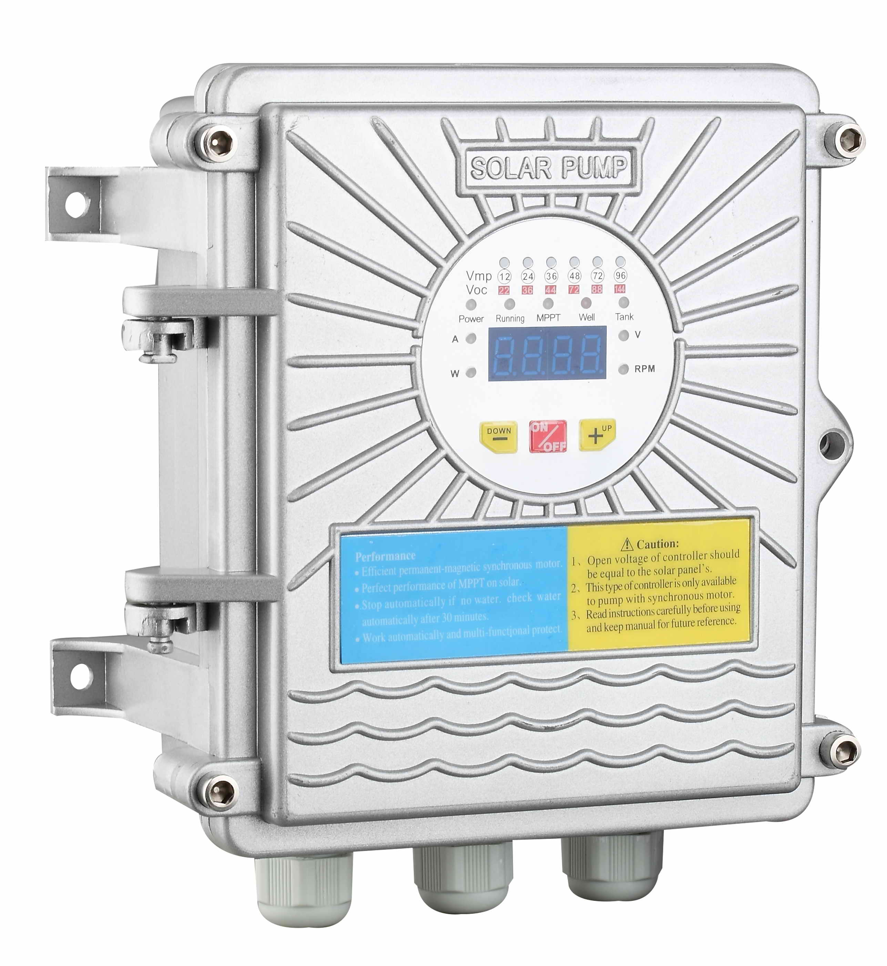picture 1. Type alow voltage controller

Type B is a common style controller for synchronous motor
Type B is a general-purpose synchronous motor controller for display panels. The operating voltage is AC220V, AC380V. Type B is a universal controller for AC and DC, having the functions of AC or DC, suitable for solar pumps with power( ≧0.75KW). It can use AC and DC at the same time. It can make solar energy and AC supply automatically. The solar energy is preferentially used, when the solar energy is insufficient, AC will supply automatically to reach the rated output of the pump. The product is shown in Picture 2

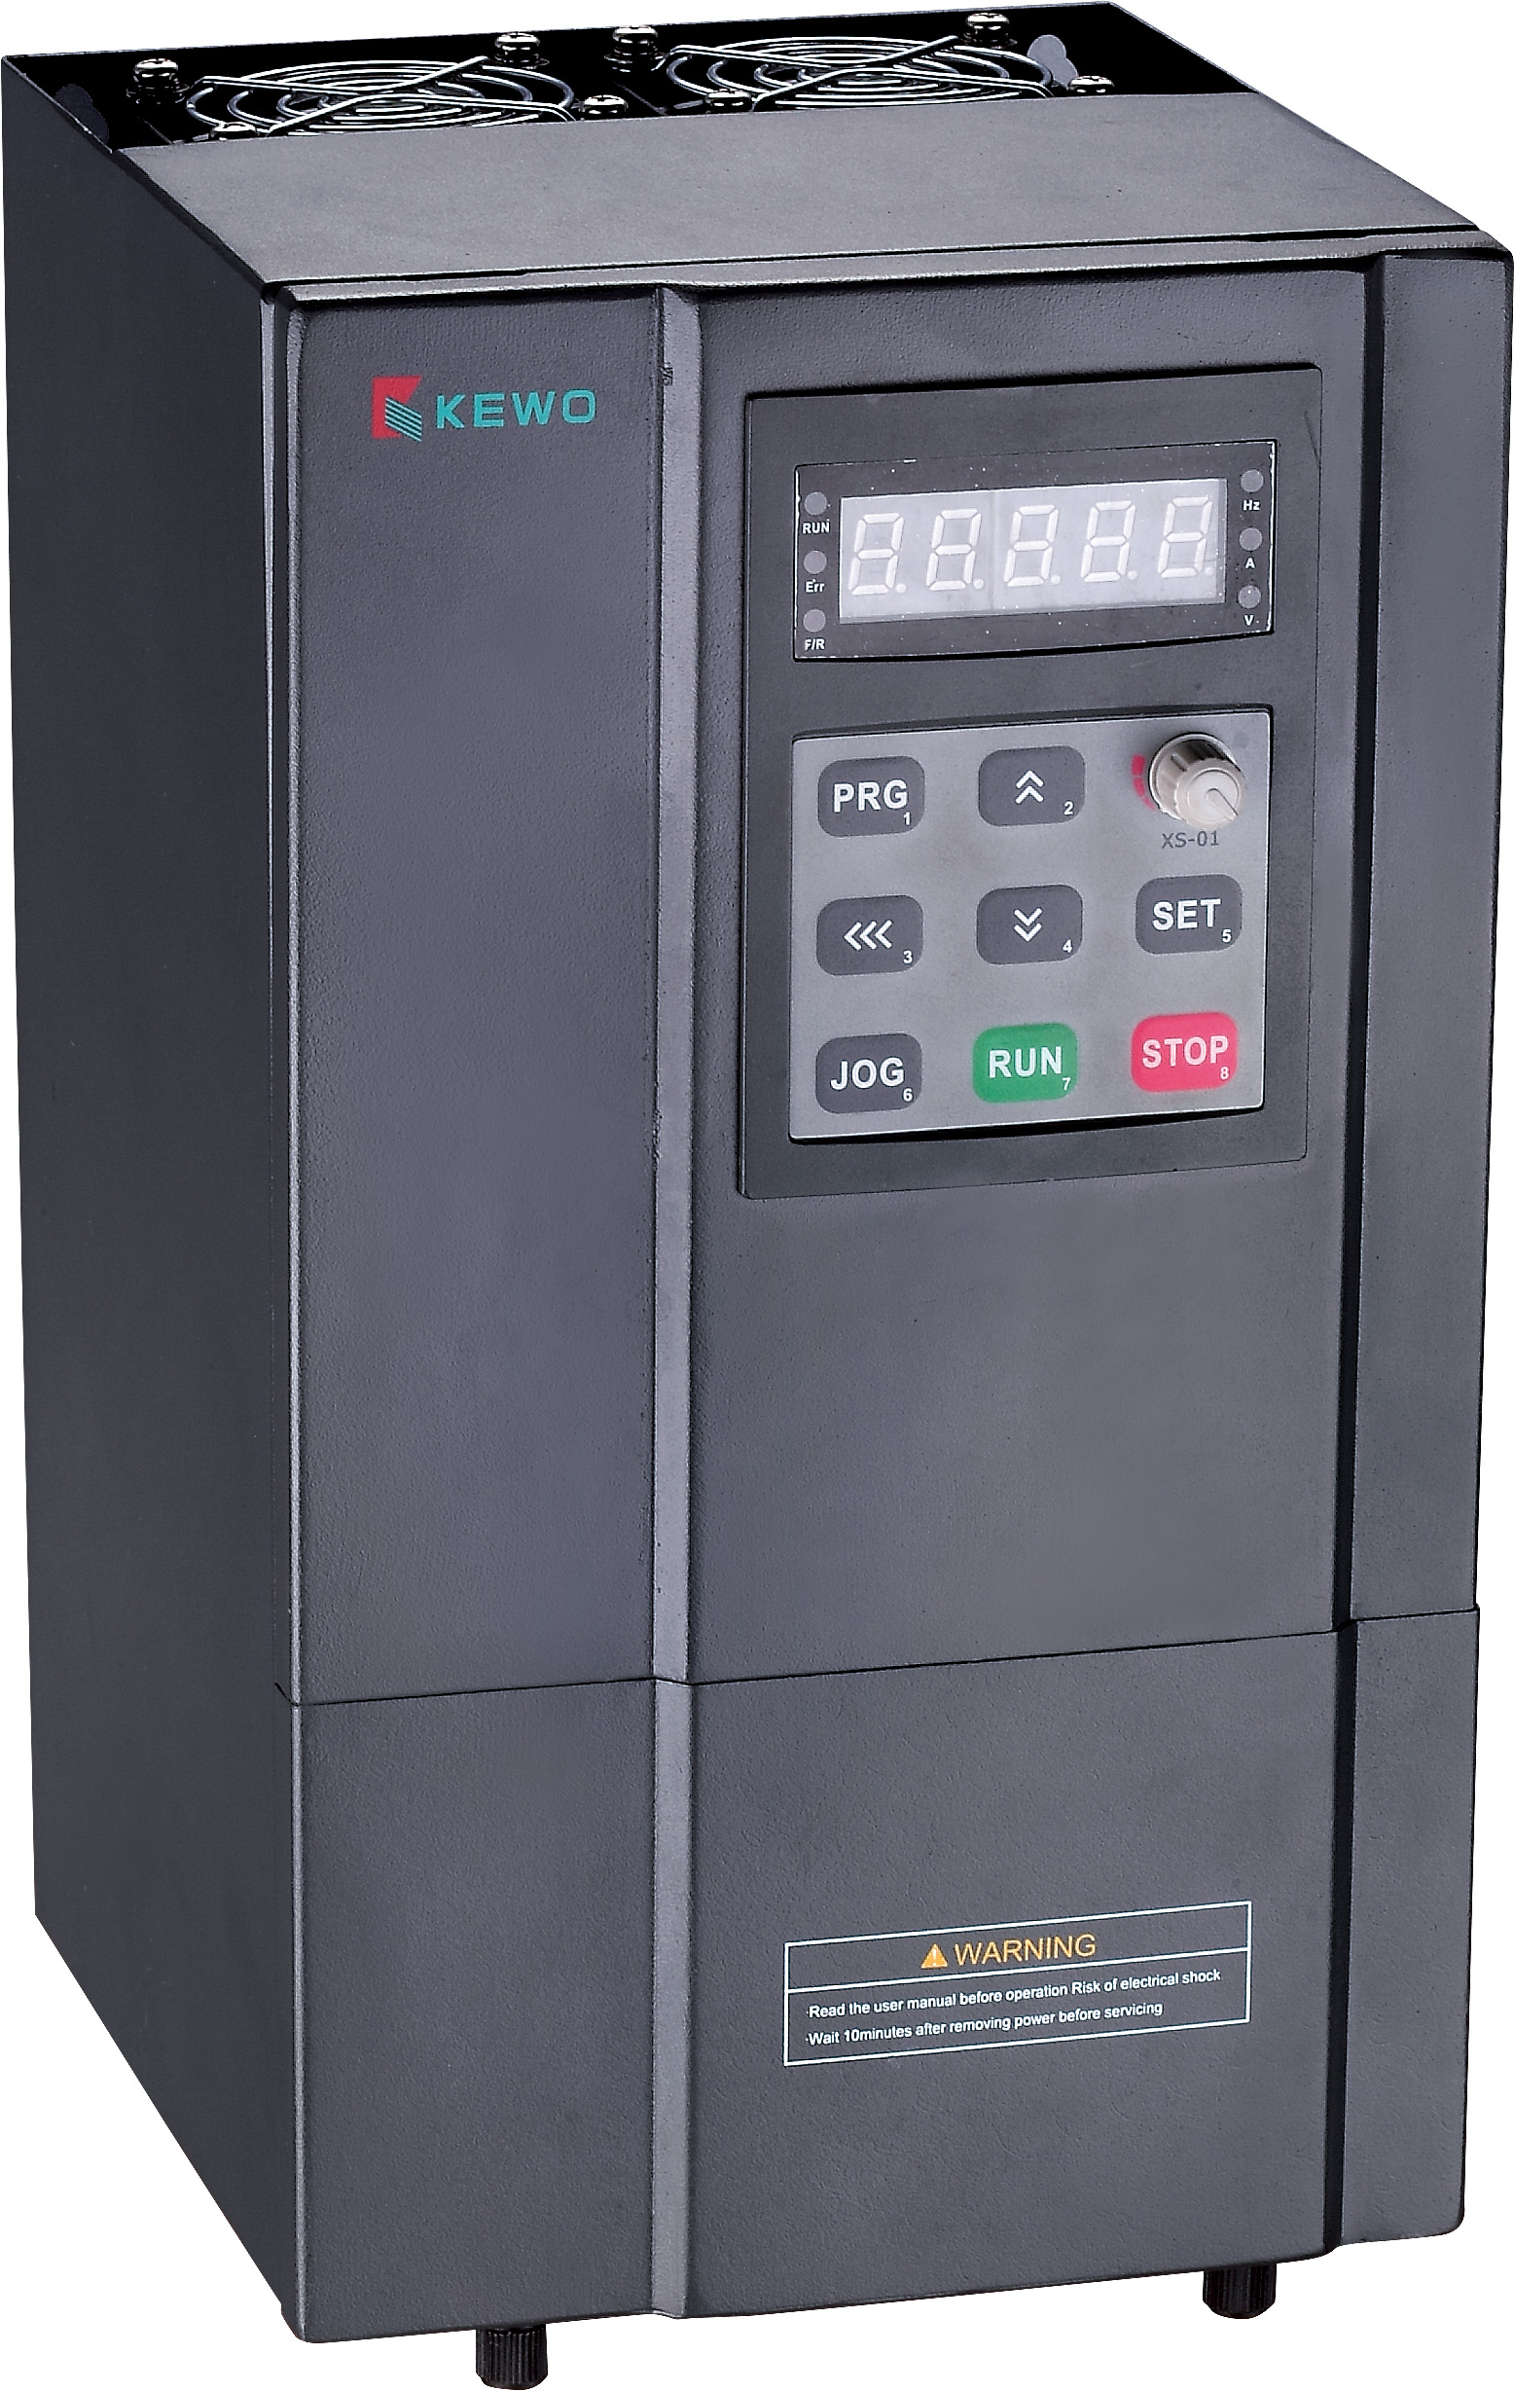picture 2 AC/DC Controller

I, The wiring and usage of A-type DC low-voltage solar pump controller

1.1 panel operation as follows:
Operation panel schematic
ON/OFF
UP
DOWN
Power
Running
Well
Tank
Mpptt
Voltage(V)
Speed(RPM)
Power(W)
Current(A)

1.1.1 Explanation of the panel light:
Power: Standby indicator lights
Running: Running lights
MPPT: Solar energy running lights (twinkling)
Well: Light indicates no water in well
Tank: Light when tank is filled with water
Current(A):Current indicator light
Power(W): Power indicatorlight
Voltage(V): Voltage indicator light
Speed(RPM): Speed indicator light

1.1.2 Panel keypad instructions:
On/Off: On/Off key Down: Speed slow down key
Down: Query Key Up: Speed up key

1.1.3 Panel button operation instructions

Pump start working at once when solar panels connect the electric. Press the switch button to turn it off, second press it to turn it on. Short press the speed minus key to display the current rotate speed, 1Hz frequency flashes on display screen. Speed data is increased or decreased at intervals of 1200 RPM when press speed button . The speed setting interval is 1200 RPM-5450 RPM. 10 seconds automatically exits the speed setting interface.

Speed reduction key reuse description: long press the speed reduction key for 1.5 seconds to enter the electrical data query interface. If you keep pressing the speed minus button, the data solar input voltage, current, and solar panel input power and speed are displayed alternately. The power-on and power-on defaults to the solar input voltage value.
1.2 scope of usage
1.2.1 Installation requirements: The controller should be installed in a place with good ventilation and heat dissipation.
1.2.2 The relationship between controller open circuit voltage, controller working voltage, solar panel input voltage is as follows, generally according to the open circuit voltage, Voc controller and pump, because the working voltage has greater differences.
Controller nominal voltage | 12V | 24V | 36V | 48V | 72V | 96V
Working voltage Vmp | 10-18V | 20-30V | 30-36V | 40-55V | 60-83V | 80-110V
Open circuit voltage Voc | 22V | 36V | 44V | 88V | 132V | 176V
Battery protection voltage V | 10V | 20V | 30V | 40V | 60V | 80V

1.3 Wiring method
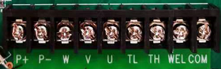

P+ is connected to the positive electrode of the solar panel, P-connected to the negative pole of the solar panel, U, V, W is connected to the three wires of the pump motor, TL is connected to bottom of the water tower on the TH is connected to upper of water tower, and the WEL is connected to the bottom float ball (the centrifugal type can not be connected, the screw The pump needs to be connected), COM is the other end of the above float switch is connected here, as a common end.

1.4 Operation Mode
When the solar panels are connected to the controller’s corresponding negative and positive part, all system starts working, the default is solar mode, then directly into the solar automatic working mode, short press the ON/OFF button to open or close the whole system. When System is open, water pumps start working with maximum speed immediately (without any fault); when the system is turned off, the pump stop running immediately.

1.4.1 Solar Mode
When plugged into a power supply, the system will automatically identify the supplied power:solar power or battery, will transferred to the corresponding program and start working. Controller is compatible with separate dc battery, solar energy which are two kinds of different ways of power supply. During solar operation mode, the water tank as well as other outage protection are effective. When solar energy separate power supply, the operation of the pump frequency will be affected by the strength of sunlight. When thesolar energy is insufficient, the controller will automatically reduce frequency to ensure the pump working speed needed to adapt to the maximum output power of solar panels, to realize the automatic tracking the maximum power point of solar energy, the MPPT light will flashing at the same time until the solar power is not enough will stop working automatically. In the second day, solar panels get solar enengy from sunshine, pump will start working automatically.
When controller detect the power is from the batteries, the system will be adjusted by the working voltage of battery frequency make full power operation, will stop working when the battery voltage discharge to protection voltage, in order to protect the batteries.

1.4.2 Manual mode
Manual mode is independent fixed frequency operation mode, the pump’s operating frequency can be set by the user.
Manual mode frequency Settings, if it is manual mode, short press “DOWN” to reduce speed, the screen will show code is "XXXX", such as "4000", it means the pump current setting speed to 4000rpm. Through the UP/DOWN buttons to adjust the required running speed, speed setting effective immediately, after 10S automatic exit setup interface, according to the parameters set during the digital screen twinkle frequency of 1 Hz.
During Manual mode, the start and stop of water pump can be done by short press the ON/OFF key, at the same time, the water tank filled with water, well no water, and other general protect downtime are still valid.

1.4.3 Float Switch Mode

Float ball model is used to water supply for the pump to the water tank, install float switches to the water tank to control the water level. Operation mode for floating switch is as following:

The pump runs automatically according to the water level of the tank and well bottom .

1, the float mode enters

Tentative boot is enabled by default and cannot be set to exit.

2, floating mode operation

Pump start condition

A, the system is powered on.

B, without any general protection.

C, insufficient water for tank (the water level is lower than tank's lowest water level ).

D, sufficient water in the well

When above four conditions are satisfied simultaneously, the pump starts immediately.

Pump shutdown condition

A, the system is shut down.

B, have universal protection.

C, full water for tank (the water level is higher than tank's lowest water level ).

D, well's lowest water level is too low.

When one of the above conditions is satisfied , the pump stops working immediately.

3. Float mode indicator

when the tank water to the water line on full (that is, the water Tank water level switch is closed), “Tank” light on screen will on. When the water level reached the waterline, light is extinguished, pump start to work.

When the well is no water (i.e., borehole water level switch is closed), “Well”light on screen will on, or go out.

1.5 General protection

1.5.1 water shortage protection

This function means that after the water in the well is pumped out, the system can automatically detect the state of water level in the well, and stop by the set program. water shortage protection is effective in all working models such as : manual, float and solar. System will restart 30 munities after water shortage protection (if start-up condition satisfied)

1.5.2 Overvoltage and Over-low voltage Protection
If the input solar DC voltage is less than the battery protection voltage and last 2 seconds continuously, over-low voltage fault will be reported . If the input voltage is higher than the maximum value of open circuit voltage of the controller, the system will give an overvoltage alarm and prohibit starting the motor. The alarm flashes with a red light

1.5.3 Current protection
After the motor starts, if the current of the motor is more than 20A, the motor will be in frequency limitation. When the current drops to 16A, the motor will return to normal operation.

1.5.4 Phase-absent protection
If all or part of the lead wire of the motor is not connected with the controller, the Phase-absent fault will be reported, and the motor will not start again, and the fault will not be eliminated. Re-energizing and troubleshooting.

1.5.5 Start-up protection
Start the motor after all the lead wires are connected with the electronic controller. If the speed is still zero after starting the motor 10 times continuously, system will report start-up failure
Fault code form
P42 | starting protection
P43 | Phase-absent protection
P49 | Current protection
P50 | DC Voltage Overlow Protection
P51 | DC Overvoltage Protection
PL | Low Power Protection of Solar Energy

1.6 Battery Selection
This controller can work with batteries. The capacity of batteries can be selected according to the same (or slightly smaller) current value A of the solar panel's power generation/voltage in a day. The positive poles of the battery and the solar panel are connected to the positive poles of the controller, and the negative poles of the battery and the solar panel are connected to the negative poles of the controller. The battery is charged directly by the solar panel. When the single-stage battery discharges to 10V, the system will shut down to protect the battery from over discharge and damage.

Ⅱ Introduction to Operation the B-type controller panel

There are two kinds of power supply for controller ,one is single phase AC 220V (including AC 110V) the other one is three phase AC 380V.
For AC 220V. following is the connection diagram: AC 220V power supply just connect to L and N , G is Grounding, this controller is not allowed to connect AC 380. otherwise ,controller would get damaged, U、V、W are output for pump supply ,which connect to three cable from pump correspondingly.
For AC 380V, following is the connection diagram : AC 380V power supply just connect to R,S,T separately , G is Grounding, U、V、W are output for pump supply ,which connect to three cable from pump correspondingly.

The three terminals R, S and T are input power terminals and three-phase supplier can use two power lines or three power lines. However, we recommend you to use three power lines. When input power is single phase, connect two input power lines to any of the three input terminals. PE(or G) are the ground-wire terminals, and both the input ground wires and the output ground wires are connected herein.
The output terminals U, V and W on the controller are the three output power wires, which are respectively connected to the black wire, blue wire and brown wire of pump: the ones with yellow and green are ground wires, which should be connected with PE(or G). All the brushless motors are working in three phases. Moreover, pay attention to the rotation direction of three-phase motor. If the direction is reversed, then the current will be increased and head will be reduced, and moreover the controller is likely to protect the pump which will stop pump from starting up. Therefore, the “U, V, W” wire connection should be done according to the manual. If the connection is found wrong, just reverse any two wires and then the direction can be adjusted．Please pay attention that change the connection of “R, S, T” will be no use.
Signal wires connection of controller: AI1, +5V, GND should be connected to the output signal from Pressure sensor, Positive and Negative Power Supply respectively; S1, +24V, COM should be connected to the output signal from flow sensor, Positive and Negative Power Supply respectively; S1, S2 +24V、COM, connected to the lower limit and upper limit of float ball, Positive and Negative Power Supply respectively. There is no terminal for water level under the well, if water level is too lower, controller current would be abnormal , pump can stops working automatically when the microcomputer detects this abnormal current.

Operation of Controller

2.1 Instruction of Operation panel

2.1.1 Schematic diagram of panel
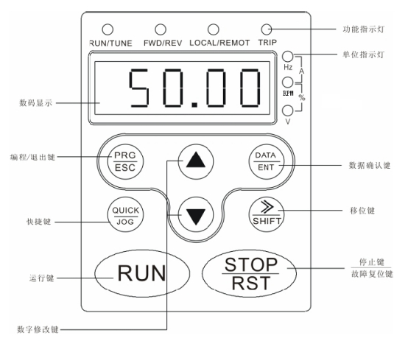

Function Indicator Light
HZ RPM V：Unit Indicator Light
Data Display
DATA/ENT：Confirm Key
PRC/ESC：Programming/Exit Key
》SHIFT：Shift Key
QUICK/JOG：Shortcut Key
Function： Run Key
Digital modification：Increment/Decrement Key
STOP/Failure Reset：Stop Key/Reset Key

2.1.2 Key Function
Key | Name | Function
 | Programming | Enter or exit Level I menu.
 | Confirm | Enter the menu interfaces level by level, and confirm the parameter setting.
 | Increment | Increase data or function code.
 | Decrement | Decrease data or function code.
+ | Confirm +quick enter | Select the displayed parameters to left in turn in the stop or running state. When operating, first keep pressing DATA/ENT, then press QUICK/JOG
 | Shift | Select the displayed parameters to the right in turn in the stop or running state, and select the digit to be modified when modifying parameters.
 | Run | Start to work in the operation panel control mode.
 | Stop/Reset | Stop working when it is in the running state and perform the reset operation when it is in the fault state. The functions of this key are restricted in P7.04
 | Quick enter | The functions of this key are set in P7.03  0：“JOG” key  1：Switch between corotation and contrarotation，  2：Clear frequency value set by UP/DOWN  3：Quick enter mode 1（fixed menu）  4：Quick enter mode 2（recent sequence）  5：Quick enter mode 3（non factory set parameter）
+ | RUN/STOP | When RUN and STOP/RST are pressed together, inverter can be stopped freely.

2.21．Set parameter
The three-level menu consists of function code group (LevelⅠ), function code (LevelⅡ), and function code setting value (Level Ⅲ).
U can return to Level Ⅱ menu from Level Ⅲ by pressing PRG or ENTER. The difference is that, after u press ENTER, the system saves the parameter setting first, and then goes back to Level Ⅱ menu and shifts to the next function code automatically. After u press PRG, the systems does not save the parameter setting, but directly returns to Level Ⅱ menu and remains at the current function code.
Here is an example of changing the value of P1.01 from 00.00Hz to 01.05Hz.
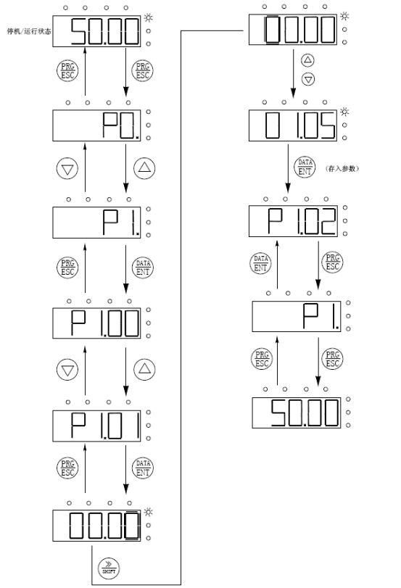

Level Ⅲ menu operation flowchart
In Level Ⅲ menu, if the parameter has no blinking digit, it means that the parameter cannot be modified. This may be because:
1). Such a function code is only readable, such as actually detected parameter and running record parameter.
2). Such a function code cannot be modified in the running state and can only be changed at stop.

Wire Connection
WARNING
- Repair or maintenance may be performed only by qualified personnel. Failure to comply will result in electric shock.
- High-voltage insulation test equipment is forbidden to test insulation performance of cable connected to inverter.
- Even inverter stops running, dangerous voltage may still exists in input power wire, DC circuit terminal and motor terminal. Thus, when power is off, we need wait another five minutes until inverter discharge to begin operation again.
- Make sure ground terminal of inverter connect to earth.
When voltage is 200v, grounding resistance should be no more than 100Ω.
When voltage is 400v, grounding resistance should be no more than 10Ω.
When voltage is 660v, grounding resistance should be no more than 5Ω.
Or else electric shock or fire can be caused.
- Make sure input terminals (R, S, T) and output terminals (U, V, W) are properly connected. Failure to comply will result in damage to inverter.
- Wet hands are not allowed to operate or else it will result in electric shock.
WARNING
- Check whether rated voltage of inverter is consistent with voltage of AC power.
- Make sure power wire and motor are connected tightly.
Flexible wire is preferred or connecting terminal will be easily broken.2.2 Connection diagram of peripheral devices

2.2.1 Photo for connection terminal

Primary circuit terminal
(+) | PB | R | S | T | U | V | W | 
(+) | PB | POWER |  |  | MOTOR
photo for primary circuit terminal (1.5～２.2kW)

(+) | PB | (-) | R | S | T | U | V | W
(+) | PB | (-) | POWER |  |  | MOTOR
photo for primary circuit terminal(4～5.5kW)

 | (+) | PB | (-) | R | S | T | U | V | W
 |  |  |  | POWER |  |  | MOTOR
photo for primary circuit terminal (7.5～15kW)

 | R | S | T | P1 | (+) | (-) | U | V | W
 | POWER |  |  | P1 | (+) | (-) | MOTOR
photo for primary circuit terminal (18.5～110kW)

Function illustration for primary circuit terminal：

2.2.2 Terminal for control circuit
485+ | 485- | +10V | S1 | S2 | S3 | S4 | HDI |  | RO1A | RO1A
AI1 | AI2 | GND | AO | COM | HDO | PW | +24V |  | RO1B | RO1C
1.5～2.2kW Photo. For terminal for control circuit of4-8

485+ | 485- | +10V | S1 | S2 | S3 | S4 | HDI |  | RO1A | RO1B | RO1C
AI1 | AI2 | GND | AO | COM | HDO | PW | +24V |  | RO2A | RO2B | RO2C
≧ 10kW Photo for terminal for control circuit of 4-9 10kW and bigger

I llustration for control terminal
Terminal name | illustration and usage for control terminal
S1～S4 | Switch input ，PW and COM optocoupler insulation input  Range of input voltage：9～30V  Input resistance：3.3kΩ
PW | External power supply ，users can connect power supply directly （together with COM ），also can use this machine as +24V power ， factory get +24V and PW short circuit for inverter MD320，if users use external power supply ,pls cut off ＋24V
+24V | this machine can be as power +24V。（current：150mA）
COM | Common terminal for +24V
AI1 | Analog input，range of voltage：0～10V  Input resistance：10KΩ
+10V | External power supply +10V。
GND | consulting zero potential for +10V。(Note：GND and COM is insulated )
AO | analog data input terminal，can choose voltage and current output thru jumper J15  Output range：voltage（0～10V）/current（0～20mA）
RO1A、RO1B、RO1C | RO1 relay output，RO1A common terminal，RO1B normal closed ，RO1C normal open  Contact capacity：AC250V/3A，DC30V/1A

Data set for solar power pump
CODE | NAME | ILLUSTRATION | DEFAULT VALUES | ALTER | No.
P0.03 | A frequency instruct choice | 0：key board set  1：analog data AI1 set  2：analog data AI2 set  3：high speed impulse HDI set  4：simple PLC procedure set  5：Multi speed running set  6：PID control set  7：remote communication set  8： panel potentiometer set | 6 | ◎
P0.09 | Max. frequency | 50.00Hz～400.00Hz | 240.00Hz | ◎
P0.11 | Up limit frequency | Lowest frequency P0.13～Max frequency P0.09 | 240.00Hz | ○
P0.16 | Speed up time 1 | 0.0s～6500.0s | 30.0s | ○
P0.17 | Speed down time 1 | 0.0s～6500.0s | 10.0s | ○
P0.18 | Trade data | 0：native data  1：factory testing data  2：bearing end data  3: civil engineering mechanics  4: dragon automatic  5: solar pump  6～8： | 5
P3.12 | Frequency range choice | 0：0～100HZ  1：0～400HZ | 1
P4.00 | S1 terminal function choice | 0： no function  1： running clockwise  2： running anticlockwise  3： three line running model  4： inch forward clockwise  5：inch forward anticlockwise  6： stop free  7： fault reset  8： running pause  9： fault coming out  10：frequency up progressively set（UP）  11：frequency down progressively set（DOWN）  12：frequency change progressively delete  13：change-over from A to B  14：（A+B）set change from A to B  15：（A+B）set change from B to A  16：Multi speed terminal 1  17：Multi speed terminal 2  18：Multi speed terminal 3  19：Multi speed terminal 4  20：Multi speed pause  21：speed change choice 1  22：speed change choice 2  23：sample PLC stop reset  24：sample PLC frequency reset  25：PID stop control  26：swing frequency stop（keep constant frequency）  27：swing frequency reset（back to center frequency）  28：arithmometer reset  29：length reset  30：speed change stop  31：arithmometer detonate input  32:arithmometer detonate input start  33：stop frequency change temporally  34：length counting input  35：length counting reset  36：up water level stop  37：down water level start  38: protect lack of water | 36
P4.01 | S2 terminal function choice |  | 37
P4.02 | S3 terminal function choice |  | 38
P4.03 | S4 terminal function choice
P4.04 | S5 terminal function choice
P4.05 | S6 terminal function choice
P9.00 | PID given source | 0：key board set  1：analog data AI1 set  2：analog data AI2 set  3：high speed impulse HDI set  4：Multi speed running set  5：remote communication set  6：panel potentiometer set  7：effective lowest solar voltage Pd.03  8：target pressure set Pd.04 | 7 | ○
P9.02 | PID feed back source | 0：analog data AI1  1：analog data AI2  2：high speed impulse HDI  3：AI1+AI2  4：AI1-AI2  5：remote communication set  6：input solar voltage sampling value  7：pressure sensor date(0～5V; analog data AI1) | 6 | ○
P9.03 | PID output characteristic choice | 0：PID output as positive characteristic  1：PID output as nagative characteristic | 1 | ○
P9.05 | proportional gain（Kp） | 0.00～100.00 | 50.00 | ○
P9.08 | Sampling period （T） | 0.01～100.00s | 0.01s | ○
Pd.03 | Lowest solar effective voltage |  | 530 | ○
Additional remarks：
1.users can not use it as pressure model and solar model at the same time。Up water level is S1 and GND；down water level is S2 and GND，water level for well is S3 and GND。
2.if users use AC power supply , should change the No.6 to 8 in P0.03；it would be constant pressure working model when PD.04 is same as PD.05
3.users can adjust the time of speed up and down；but can not set the Max. frequency or up frequency higher than the data which set by factory, otherwise, it will get damage.
4.users is forbidden to change other data without factory’s instruction .

FAULT AND SOLUTION
FAULT CODE | FAULT FIELD | FAULT REASON | HANDLE | SOLUTION | SERIESS
E-01 | Output short circuit | 1：check motor coil  2：check power cable  3：speed down too fast | P0.17 | 1：replace motor  2：replace motor  3：prolong the time
E-02 | Speed up overcurrent | Speed up too fast  Controller too small | P0.16 | prolong the time  Change a bigger controller
E-03 | Speed down overcurrent | Speed down too fast  Controller too small | P0.17 | prolong the time  Change a bigger controller
E-04 | Constant speed overcurrent | Overload suddenly |  | Check load
E-05  E-06 | Speed up overvoltage  Speed down overvoltage | Input voltage is too high  Speed down too fast | Check the input voltage  P0.17 | Check the input voltage  prolong the time
E-07 | Constant speed overvoltage | Protecting voltage set too low | Pd.11 | Set protecting voltage higher
E-08 | Power supply under voltage | Input voltage too low | Check the input voltage | Check the input voltage
E-09 | overload | Overload suddenly |  | Check load
E-10 | Controller overload | Controller too small |  | Change a bigger controller
E-11 | Input lacking phase | Input voltage lacking phase | Measure input voltage | Check input voltage
E-12 | Output lacking phase | Input voltage or motor lacking phase | Measure the input voltage or check the resistance of motor coil | Input voltage or motor lacking phase
E-13  E-14 | Rectifier module overheat  inverter module overheat | vent block up or fan get broken  Temperature is too high  Cable connection or plug on controller panel get loose |  | Unclog vent or replace the fan  Lower the temperature  Check and reconnection

Ⅲ，Technical specifications and parameters
Low Voltage Small Power Solar Pump Series, Controller External

MODEL | IMPUT POWER  W | VMP  V | SOLAR POWER  W | HEAD  RATED/MAX  M | FLOW  RATED/MAX  T/h | HEIGHT  M | N.W.  Kg | OUTLET  mm | PACKING  mm
3SSW1.8-16-24-120 | 120 | DC24V | 168 | 9/16 | 0.5/18 | 480 | 4.6 | 25 | 120*120*520
3SSW2-22-24-180 | 180 | DC24V | 252 | 15/22 | 0.8/20 | 480 | 4.6 | 25 | 120*120*520
3SSW1.8-16-48-120 | 120 | DC48V | 168 | 9//16 | 0.5/18 | 480 | 4.6 | 25 | 120*120*520
3SSW2-18-48-150 | 150 | DC48V | 210 | 13/18 | 0.7/20 | 480 | 4.9 | 25 | 120*120*520
3SSW2.5-30-48-200 | 200 | DC48V | 280 | 20/30 | 0.7/25 | 480 | 4.6 | 25 | 120*120*520
3SSW2.6-40-48-400 | 400 | DC48V | 560 | 30/40 | 1/2.6 | 510 | 4.9 | 25 | 120*120*600
3SSW2.7-52-48-550 | 600 | DC48V | 840 | 40/52 | 1/2.7 | 540 | 5.3 | 25 | 120*120*600
3SSW3-63-48-600 | 600 | DC48V | 840 | 48/63 | 1/3.0 | 540 | 5.3 | 25 | 120*120*600
3SSW3-78-48-750 | 750 | DC48V | 1050 | 60/78 | 1/3.0 | 580 | 5.3 | 25 | 120*120*600
3SSW3-22-48-300 | 300 | DC48V | 420 | 16//22 | 2/3.0 | 480 | 5.3 | 25 | 120*120*500
3SSW4-33-48-550 | 550 | DC48V | 770 | 22/33 | 2/4.0 | 500 | 5.3 | 25 | 120*120*600
3SSW5-40-48-750 | 750 | DC48V | 1050 | 33/40 | 2/5.0 | 500 | 5.8 | 25 | 150*150*600
3SSW3-120-72-1100 | 1100 | DC72V | 1540 | 45/120 | 1/3 | 680 | 6.0 | 25 | 120*120*700
3SSW5-70-72-1100 | 1100 | DC72V | 1540 | 50/70 | 3/5 | 580 | 5.8 | 25 | 120*120*600
3SSW5-80-96-1300 | 1300 | DC96V | 1820 | 63/80 | 3/5 | 580 | 5.8 | 25 | 120*120*600

3 INCH PUMP
MODEL | FLOW  RATED/MAX | HEAD  RATED/MAX | Input powerKW | SOLAR POWER  KW | VMP  V | Speed r/min | HEIGHT  mm | N.W.  Kg | OUTLET  mm | DIA.  mm | PACKING  mm
3SZW2-50-0.75 | 2/5 | 50/70 | 1.4 | 1.5 | AC220V/  DC300V | 6000 | 500 | 5.5 | 32 | 75 | 120*120*520
3SZW2-65-1.1 | 2/5 | 65/80 | 1.82 | 2.1 | AC220V/  DC300V | 6000 | 540 | 5.8 | 32 | 75 | 120*120*600
3SZW3-50-1.1 | 3/5 | 50/80 | 1.82 | 2.1 | AC220V/  DC300V | 6000 | 540 | 5.8 | 32 | 75 | 120*120*600
3SZW2-100-1.5 | 2/6 | 100/120 | 2.52 | 2.8 | AC220V/  DC300V | 6000 | 580 | 6.3 | 32 | 75 | 120*120*600
3SZW3-80-1.5 | 3/6 | 80/120 | 2.52 | 2.8 | AC220V/  DC300V | 6000 | 460 | 6.3 | 32 | 75 | 120*120*520

4 INCH PUMP
MODEL | FLOW  RATED/MAX | HEAD  RATED/MAX | Input powerKW | SOLAR POWER  KW | VMP  V | Speed r/min | HEIGHT  mm | N.W.  Kg | OUTLET  mm | PACKING  mm
4SZW8-20-0.75 | 8/12 | 20/25 | 0.9 | 1.26 | AC220V/  DC300V | 4200 | 550 | 9.4 |  | 150*150*600
4SZW8-26-1.1 | 8/13 | 26/36 | 1.38 | 1.93 | AC220V/  DC300V | 5000 | 550 | 9.4 | 38 | 150*150*600
4SZW2-70-1.1 | 2/7 | 70/85 | 1.4 | 1.96 | AC220V/  DC300V | 5000 | 620 | 10.1 | 38 | 150*150*700
4SZW3-50-1.1 | 3/8 | 50/65 | 1.4 | 1.96 | AC220V/  DC300V | 5000 | 600 | 9.9 | 38 | 150*150*700
4SZW4-40-1.1 | 4/6.6 | 40/48 | 1.3 | 1.82 | AC220V/  DC300V | 5000 | 570 | 9.6 | 38 | 150*150*600
4SZW10-18-1.1 | 10/20 | 18/22 | 1.29 | 1.86 | AC220V/  DC300V | 4000 | 550 | 9.5 | 38 | 150*150*600
4SZW2-100-1.5 | 2/7 | 100/115 | 1.85 | 2.59 | AC220V/  DC300V | 5000 | 710 | 10.7 | 38 | 150*150*800
4SZW5-50-1.5 | 5/10 | 50/85 | 1.85 | 2.59 | AC220V/  DC300V | 5000 | 600 | 10.1 | 38 | 150*150*700
4SZW6-45-1.5 | 6/12 | 45/65 | 1.85 | 2.59 | AC220V/  DC300V | 5200 | 570 | 9.8 | 38 | 150*150*600
4SZW10-30-1.5 | 10/14 | 30/44 | 1.8 | 2.52 | AC220V/  DC300V | 5000 | 580 | 9.8 | 38 | 150*150*600
4SZW13-22-1.5 | 13/23 | 22/28 | 1.85 | 2.59 | AC220V/  DC300V | 5000 | 540 | 9.6 | 50 | 150*150*600
4SZW10-37-1.8 | 10/14 | 37/52 | 2.35 | 3.29 | AC220V/  DC300V | 5000 | 570 | 9.8 | 38 | 150*150*600
4SZW10-45-2.2 | 10/14 | 45/60 | 2.8 | 3.9 | AC220V/  DC300V | 4800 | 665 | 11.1 | 38 | 150*150*700
4SZW3-130-2.2 | 3/8 | 130/150 | 2.8 | 3.9 | AC220V/  DC300V | 5000 | 790 | 12.5 | 38 | 150*150*800
4SZW2-180-2.2 | 2/7 | 180/195 | 2.7 | 3.8 | AC220V/  DC300V | 5000 | 930 | 13.5 | 38 | 150*150*1000
4SZW8-60-2.2 | 8/12 | 60/85 | 2.59 | 3.6 | AC220V/  DC300V | 5000 | 690 | 11.3 | 38 | 150*150*700
4SZW16-25-2.2 | 16/26 | 25/35 | 2.63 | 3.682 | AC220V/  DC300V | 5000 | 605 | 11.1 | 50 | 150*150*700
4SZW10-58-3 | 10/14 | 58/74 | 3.65 | 5.1 | AC380V/  DC520V | 5000 | 685 | 12.0 | 38 | 150*150*700
4SZW3-175-3 | 3/5 | 175/198 | 3.85 | 5.39 | AC380V/  DC520V | 5000 | 885 | 14.0 | 38 | 150*150*900
4SZW5-100-3 | 5/8 | 100/120 | 3.57 | 5.0 | AC380V/  DC520V | 5000 | 740 | 12.7 | 38 | 150*150*800
4SZW10-50-3 | 10/14 | 50/65 | 3.57 | 5.0 | AC380V/  DC520V | 5000 | 660 | 11.8 | 38 | 150*150*700
4SZW18-30-3 | 18/29 | 30/42 | 3.31 | 4.6 | AC380V/  DC520V | 4600 | 650 | 11.5 | 50 | 150*150*700
4SZW6-120-4 | 6/8 | 120/142 | 5.1 | 7.14 | AC380V/  DC520V | 5000 | 770 | 13.7 | 38 | 150*150*800
4SZW10-80-4 | 10/14 | 80/110 | 5.2 | 7.28 | AC380V/  DC520V | 5000 | 735 | 13.3 | 38 | 150*150*800
4SZW4-160-4 | 4/6 | 160/185 | 5.2 | 7.28 | AC380V/  DC520V | 5000 | 860 | 14.4 | 50 | 150*150*900
4SSZW20-45-4 | 20/32 | 45/57 | 5.31 | 7.4 | AC380V/  DC520V | 5200 | 685 | 13.1 | 50 | 150*150*700
4SZW5-200-5.5 | 5/8 | 200/267 | 7.2 | 10 | AC380V/  DC520V | 5000 | 970 | 16.2 | 38 | 150*150*1000
4SZW6-150-5.5 | 6/8 | 150/178 | 6.5 | 9.1 | AC380V/  DC520V | 5000 | 890 | 14.8 | 38 | 150*150*900
4SZW10-120-5.5 | 10/14 | 120/148 | 7.3 | 10.2 | AC380V/  DC520V | 5000 | 860 | 14.9 | 38 | 150*150*900
4SZW20-55-5.5 | 20/30 | 55/75 | 6.9 | 9.66 | AC380V/  DC520V | 5000 | 725 | 14.3 | 50 | 150*150*8000
4SZW10-150-7.5 | 10/18 | 150/210 | 8.8 | 12.32 | AC380V/  DC520V | 5000 | 970 | 18.9 | 38 | 150*150*1000
4SZW20-80-7.5 | 20/28 | 80/90 | 9.1 | 12.74 | AC380V/  DC520V | 5000 | 815 | 18.2 | 50 | 150*150*900
4SZW5-240-7.5 | 5/8 | 240/300 | 9.1 | 12.74 | AC380V/  DC520V | 5000 | 1070 | 19.7 | 38 | 150*150*1100

6 INCH PUMP
MODEL | FLOW  RATED/MAX | HEAD  RATED/MAX | Input powerKW | SOLAR POWER  KW | VMP  V | Speed r/min | HEIGHT  mm | N.W.  Kg | OUTLET  mm | PACKING  mm
6SZW17-25-1.8 | 17/50 | 25/26.5 | 2.16 | 3.024 | AC220V  DC300V | 4000 | 850 | 37.7 | 75 | 200*200*890
6SZW25-20-2.2 | 25/46 | 20/23 | 2.62 | 3.668 | AC220V  DC300V | 4000 | 850 | 37.7 | 75 | 200*200*890
6SZW30-22-3 | 30/51 | 22/27 | 3.63 | 5.082 | AC380V/  DC520V | 4000 | 850 | 37.7 | 75 | 200*200*890
6SZW25-25-3 | 25/45 | 25/32 | 3.72 | 5.208 | AC380V/  DC520V | 4000 | 850 | 37.7 | 75 | 200*200*890
6SZW50-18-4 | 50/76 | 18/26 | 4.8 | 6.72 | AC380V/  DC520V | 4000 | 930 | 39.7 | 100 | 200*200*960
6SZW45-25-5.5 | 40/65 | 25/55 | 6.7 | 9.38 | AC380V/  DC520V | 4000 | 930 | 39.7 | 75 | 200*200*960
6SZW25-50-5.5 | 25/45 | 50/80 | 6.7 | 9.38 | AC380V/  DC520V | 4000 | 855 | 38.9 | 75 | 200*200*890
6SZW70-22-7.5 | 70/103 | 22/39 | 8.75 | 12.25 | AC380V/  DC520V | 4000 | 1150 | 65.5 | 100 | 200*200*1180
6SZW20-110-11 | 20/40 | 110/146 | 13 | 18.2 | AC380V/  DC520V | 4000 | 990 | 42.5 | 75 | 200*200*1020
6SZW50-45-11 | 50/70 | 45/82 | 12.9 | 18.06 | AC380V/  DC520V | 4000 | 1000 | 42.5 | 75 | 200*200*1030
6SZW25-130-15 | 25/40 | 130/200 | 17.6 | 24.64 | AC380V/  DC520V | 4000 | 1035 | 43.7 | 75 | 200*200*1080
6SZW25-150-18.5 | 25/40 | 150/200 | 21.8 | 30.52 | AC380V/  DC520V | 4000 | 945 | 45 | 75 | 200*200*975
6SZW50-90-22 | 50/70 | 90/134 | 25.8 | 36.12 | AC380V/  DC520V | 4000 | 1210 | 48 | 100 | 200*200*1240
6SZW25-180-22 | 25/40 | 180/226 | 25.8 | 36.12 | AC380V/  DC520V | 4000 | 1135 | 46.3 | 75 | 200*200*1170
6SZW25-250-30 | 25/45 | 250/296 | 34 | 47.6 | AC380V/  DC520V | 4000 | 1275 | 48.4 | 75 | 200*200*1300
6SZW40-150-30 | 40/70 | 150/193 | 34 | 47.6 | AC380V/  DC520V | 4000 | 1340 | 49.5 | 75 | 200*200*1400
6SZW25-300-37 | 25/40 | 300/385 | 41 | 57.4 | AC380V/  DC520V | 4000 | 1365 | 52 | 75 | 200*200*1400

8 INCH PUMP
MODEL | FLOW  RATED/MAX | HEAD  RATED/MAX | Input powerKW | SOLAR POWER  KW | VMP  V | Speed r/min | HEIGHT  mm | N.W.  Kg | OUTLET  mm | PACKING  mm
8SZW100-32-13 | 100/136 | 32/49 | 14.6 | 20.44 | AC380V/  DC520V | 4000 | 890 | 39/6 | 100 | 290*290*1000
8SZW100-40-15 | 100/140 | 40/50 | 16.8 | 23.52 | AC380V/  DC520V | 4000 | 890 | 39/6 | 100 | 292*290*1000
8SZW130-30-18.5 | 130/162 | 30/49 | 20.1 | 28.14 | AC380V/  DC520V | 4000 | 900 | 39/6 | 100 | 290*292*1000
8SZW50-100-22 | 50/69 | 100/140 | 24.3 | 34.02 | AC380V/  DC520V | 4000 | 920 | 45.5/6 | 100 | 290*290*1000
8SZW130-35-22 | 130/165 | 35/55 | 24.3 | 34.02 | AC380V/  DC520V | 4000 | 920 | 43/6 | 100 | 292*290*1000
8SZW100-65-30 | 70/95 | 100/140 | 33.2 | 46.48 | AC380V/  DC520V | 4000 | 1040 | 47/6 | 100 | 290*292*1100
8SZW30-180-30 | 30/40 | 180/220 | 33.6 | 47.04 | AC380V/  DC520V | 4000 | 1300 | 70 | 75 | 290*292*1400
8SZW100-85-37 | 100/136 | 85/120 | 40.1 | 56.14 | AC380V/  DC520V | 4000 | 1120 | 78 | 100 | 290*290*1200
8SZW130-70-45 | 130/165 | 70/95 | 49.6 | 20.44 | AC380V/  DC520V | 4000 | 970 | 60 | 100 | 292*290*1100
8SZW130-100-55 | 130/160 | 100/135 | 59.2 | 23.52 | AC380V/  DC520V | 4000 | 1120 | 65 | 100 | 290*292*1200
Ⅳ：Notice for Using Pump
4.1. If pump is working on its rated head, then pump can be displaced 50 meter under the water. Before working, please check that whether the pump is good condition, no loose connection, no seepage and leakage of oil and no damage of cable. Use the ohmmeter to measure insulation electric resistance of pump. When the pump is in cold conditions, the electric resistance can be ≥50MΩ, and when the pump is in hot conditions, the electric resistance can be ≥2MΩ.
4.2. The pump power requirement is ±10%. When the controller output power is constant and the voltage is too low, the output current will increase and reach the upper limit of the controller for protection so that the controller will stop working. At this time we should change the pump to manual working mode and slow down the speed a bit.
4.3. The pump should be equipped with its unique electric brake and switch separately. Ground terminals on the pump housing should be connected to the ground wire. Wires in green and yellow colors are ground wires and should be connected the ground accordingly.
When the cables equipped on the electric pump are not long enough and should be lengthened, the diameter of the lengthened cable must be larger than the previous one. Use waterproof adhesive tape to seal the joint.
4.4．Before using, connect the pump to power supply and check whether it’s starting and running are normal. Please note that pump should work in counterclockwise direction. Keep the pump working in short time to check whether the rotation direction of the electric pump is correct，pump is forbids running without water. If the rotation direction of the three-phase electric pump is not correct, then adjust any two of the power input lines.
4.5．The installing and hoisting of electric pump should be performed at the
annular ring by the lifting rope．It is forbidden to lift the cable to hoist the electric pump. pump should be placed more than 1 m away from the bottom so as to prevent the suction of sediment and avoid the damage of components such as machine ring and impellers．
4.6．Pay attention to the water level when the electric pump is working, especially when it is working under the well．Never keep the electric pump work emerging the water level or without water, otherwise the motor and other components may be damaged. Also the pump can’t work under sludge or the motor will be damaged because of poor heat dissipation.

Ⅴ Maintenance
5.1．It is a must to replace vulnerable parts(such as bearing．seal ring，mechanical seal etc．）once the electric pump has run 3000 hoursaccumulatively so as to avoid greater loss resulting from the damage of machine parts.
5.2．It is recommended to wash and wipe the electric pump for long time nonuse and then place it to a ventilated and dry place for keeping properly according to the actual peeling condition of the surface paint coat．

PROBLEM | CAUSE | SOLUTION
Motor cannot run | - Power cable connect with controller wrongly  - Controller is in the fault protection state  - Pump impeller is blocked and motor cannot start  - Pump motor damaged  - Controller damaged | - Check the cable connection  - Check all connection and set the controller all over again  - Check the pump body ,make sure impeller can turn freely  - Please contact repair and service agent when you have no idea with the fault
No water out or water flow is small | - Motor run reversely  - Pump inlet strainer is blocked  - Impellers wear seriously  - Winding coil burned | - Exchange the input cable  - Remove the jam  - Replace the impeller  - Replace motor

