在使用本产品前，应先阅读本说明书。
危险 警告△
Before using the pump, please read the following introduction carefully.
Instruction Book
说明书

在使用本产品前，应先阅读本说明书。

本产品是本公司的发明专利，高效高速的永磁直流无刷电机驱动的深井泵，和普通深井泵相比，具有高速高效，体积小（是同规格扬程流量的井泵（1/5），重量轻（是同规格扬程流量的井泵（1/5），智能化操作，能通过压力、流量、进行恒流恒压控制运行，能通过浮球限位及其他方法控制运行，能定时开机关机，井下无水保护，及泵电机过热过流等各种自动保护，有电压、电流、水压力、流量、电机转速等工作状态显示，出现故障有代码指示。后期型号还开发具有通讯端口，实现电脑网络控制功能。
危险 警告△： 本产品的泵电机三根线不能接其他任何电源，只能接配套控制器的UVW三个端子上。本产品由泵和控制器两部份组成，每个型号的控制器的使用电压都有严格要求的，要按规定的电源电压接入才能正常使用，过高的电压接入会使控制器造成永久损坏。泵和对应型号的控制器配套使用，不能够和其他的泵或控制器使用，否则无法工作还会损坏本产品。

控制器有A型和B型两个系列。A型是用于太阳能低压（DC24-96V）专用，面板有电压，电流，压力，流量，频率等四组数码管显示模式的太阳能泵控制器。功能有电源、工作指示灯，MPPT状态，水井缺水指示，水箱满水按要求等工作状态，如图1 。
This product is one of the invention patents of our company and is a kind of
deep-Well pump that is driven by brushless high-Speed motor．Compared with conventional
deep-well pump, this product is characterized by high speed, high efficiency, small volume
(only 1/5 of deep well pump with same flow and head), light weight (only 1/5 of deep well
pump with same flow and head) and intelligent operation. It can control the operation
featuring constant current and constant voltage by means of pressure and flow. It can also
control the operation by limiting the floating ball and other methods. It can switch on and
switch off by setting a time. It can perform waterless protection under the well and can
protect pump motor from overheating and over current automatically．The pump can show
the working status of voltage, current, water pressure, flow and speed of motor and can send
out a code indication once failure occurs. In addition, the pump can provide with a
communication interface capable of controlling the computer network in the near future．
Warning: the three wires on the motor can only be connected to “U, V, W” terminals
on the controller and can’t be connected to other power terminals.
This product is composed of pumps and controllers. Each model is equipped with a
unique controller and cannot be used with other controllers, otherwise failure or damage to
this product would be caused．
The controller has two types, A and B. Type A is a professional controller for solar low voltage (DC24-96V) pump, there are four sets of parameters on display screen, voltage, current, pressure, flow and frequency. The function has power supply, work indicator, MPPT status, water well water shortage indication, water tank full water as required, etc., as shown in picture 1.

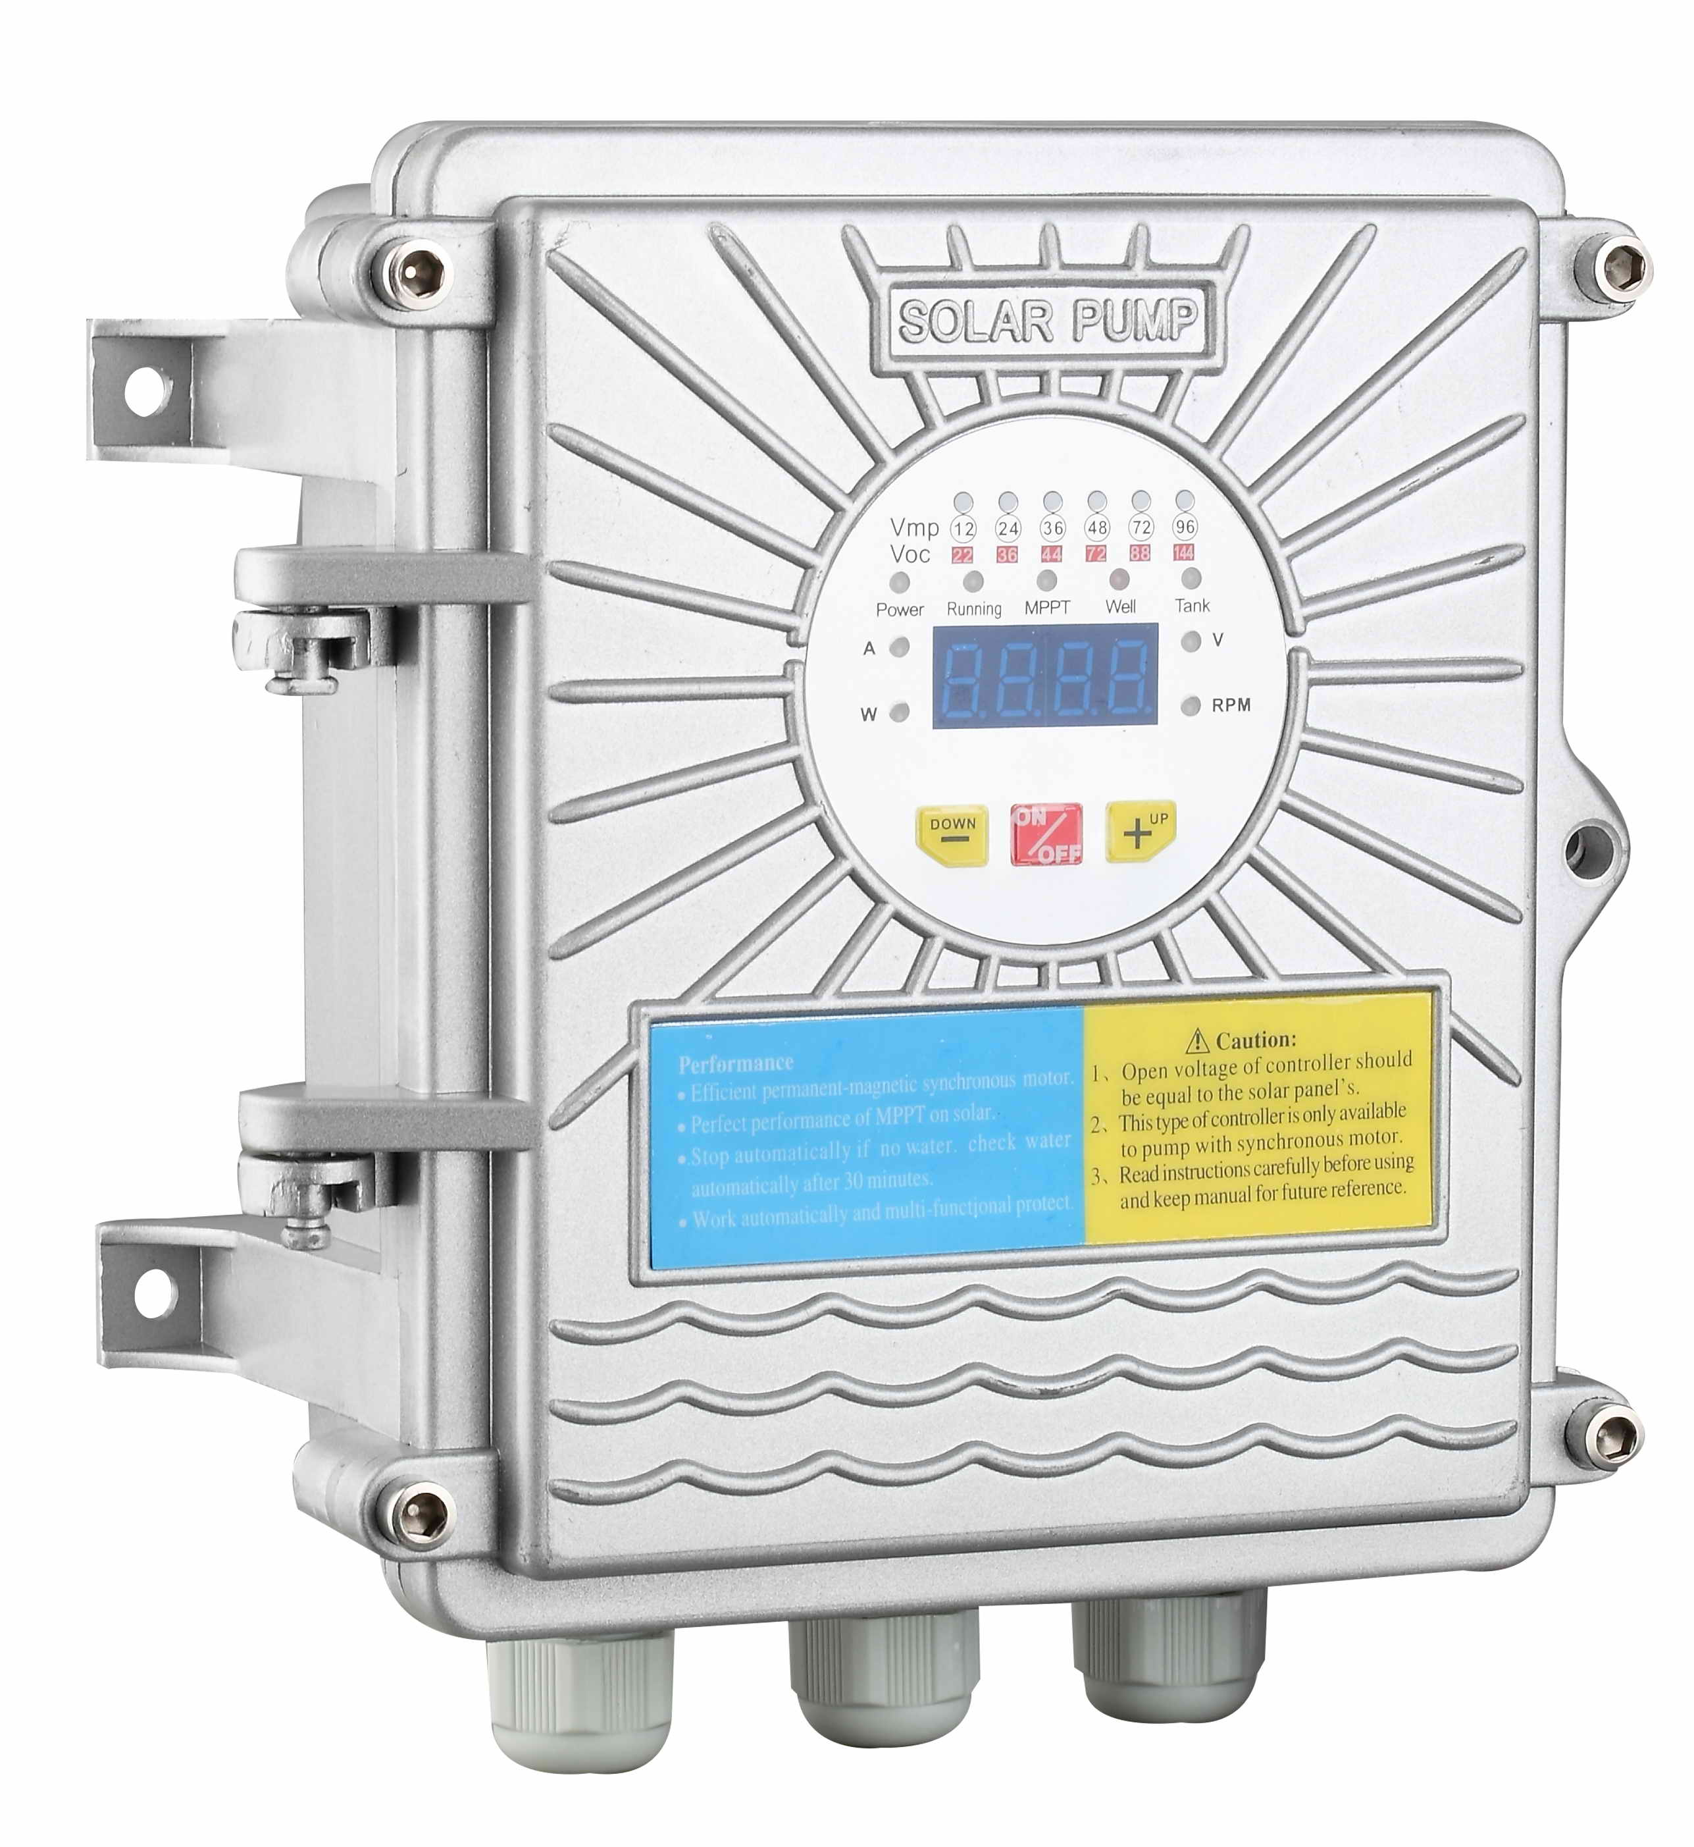图1 A型低压控制器
picture 1. Type alow voltage controller

B型是显示面板的为通用型的同步电机控制器，这类控制器工作电压是AC220V,AC380V的，适用于功率≧0.75KW以上的太阳能泵，是AC和DC通用型控制器。这类控制器具有AC或DC都可使用的功能，也可以同时使用AC和DC，能够在太阳能和交流之间自动互补功能 ，优先使用太阳能，太阳能不足交流电补充，达到泵的额定输出。产品见图2.
Type B is a common style controller for synchronous motor
Type B is a general-purpose synchronous motor controller for display panels. The operating voltage is AC220V, AC380V. Type B is a universal controller for AC and DC, having the functions of AC or DC, suitable for solar pumps with power( ≧0.75KW). It can use AC and DC at the same time. It can make solar energy and AC supply automatically. The solar energy is preferentially used, when the solar energy is insufficient, AC will supply automatically to reach the rated output of the pump. The product is shown in Picture 2

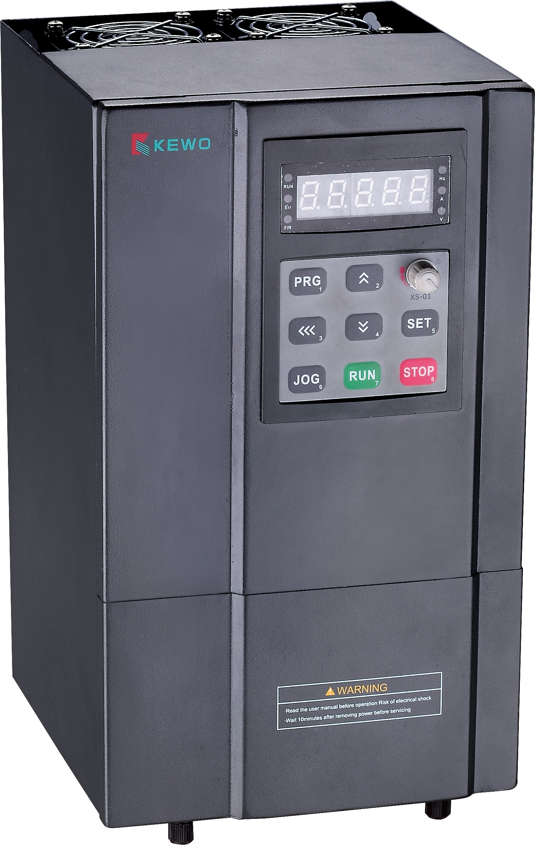图2 通用型高压AC/DC控制器

一，A 型DC低电压太阳能泵控制器的接线与使用方法
I, the wiring and usage of A-type DC low-voltage solar pump controller

1.1面板操作介绍如下：
操作面板示意图1.1 panel operation as follows:
Operation panel schematic
图3 显示面板

ON/OFF
UP
DOWN
Power
Running
Well
Tank
Mpptt
Voltage(V)
Speed(RPM)
Power(W)
Current(A)

1.1.1面板指示灯说明：

Power: 上电待机指示灯 Running:运行指示灯

Mppt:太阳能运行指示灯(闪烁) Well:水井缺水指示灯

Tank:水箱水满指示灯 Current(A):电流指示灯

Power(W):功率指示灯 Voltage(V):电压指示灯

Speed(RPM):转速指示灯

1.1.1 Explanation of the panel light:
Power: Standby indicator lights
Running: Running lights
MPPT: Solar energy running lights (twinkling)
Well: Light indicates no water in well
Tank: Light when tank is filled with water
Current(A):Current indicator light
Power(W): Power indicatorlight
Voltage(V): Voltage indicator light
Speed(RPM): Speed indicator light

1.1.2面板按键说明：

On/Off:开关机键 Down:转速减键

Up:转速加键

1.1.2 Panel keypad instructions:
On/Off: On/Off key Down: Speed slow down key
Down: Query Key Up: Speed up key

1.1.3面板按键操作说明：1.1.3 Panel button operation instructions

当太阳能板接上电后便会运行，按开关机键便关机，再按则开机。短按转速减键显示当前设定转速，显示屏1Hz频率闪烁。每短按一次转速加键或减键，转速值以1200RPM间隔增加或降低，转速设定区间1200RPM-5450RPM。10秒自动退出转速设定界面。

转速减键复用说明：长按转速减键1.5秒进入电气数据查询界面。如果一直长按转速减键则显示数据太阳能输入电压，电流，以及太阳能板输入功率和转速之间轮流显示。上电开机默认显示太阳能输入电压值。 Pump start working at once when solar panels connect the electric. Press the switch button to turn it off, second press it to turn it on. Short press the speed minus key to display the current rotate speed, 1Hz frequency flashes on display screen. Speed data is increased or decreased at intervals of 1200 RPM when press speed button . The speed setting interval is 1200 RPM-5450 RPM. 10 seconds automatically exits the speed setting interface.

Speed reduction key reuse description: long press the speed reduction key for 1.5 seconds to enter the electrical data query interface. If you keep pressing the speed minus button, the data solar input voltage, current, and solar panel input power and speed are displayed alternately. The power-on and power-on defaults to the solar input voltage value.
1.2使用范围1.2 scope of usage
1.2.1安装要求：控制器尽可能安装在通风良好便于散热的场所。
1.2.2控制器开路电压，控制器工作电压，太阳能板输入电压三者关系按下表配备，一般按开路电压Voc配置控器和泵，因为工作电压会有较大的差别。
控制器标称电压 | 12V | 24V | 36V | 48V | 72V | 96V
工作电压Vmp | 10-18V | 20-30V | 30-36V | 40-55V | 60-83V | 80-110V
开路电压Voc | 22V | 36V | 44V | 88V | 132V | 176V
蓄电池保护电压V | 10V | 20V | 30V | 40V | 60V | 80V
1.2.1 Installation requirements: The controller should be installed in a place with good ventilation and heat dissipation.
1.2.2 The relationship between controller open circuit voltage, controller working voltage, solar panel input voltage is as follows, generally according to the open circuit voltage, Voc controller and pump, because the working voltage has greater differences.
Controller nominal voltage | 12V | 24V | 36V | 48V | 72V | 96V
Working voltage Vmp | 10-18V | 20-30V | 30-36V | 40-55V | 60-83V | 80-110V
Open circuit voltage Voc | 22V | 36V | 44V | 88V | 132V | 176V
Battery protection voltage V | 10V | 20V | 30V | 40V | 60V | 80V

1.3接线方法Wiring method
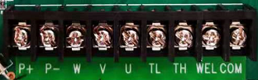

P+接太阳能板正极，P-接太阳能板负极，U,V,W接泵电机的三根线，TL接水塔下水位TH接水塔上水位，WEL接井底浮球（离心式可以不接，螺杆式泵需要接入），COM是以上浮球开关的另一端都接在此，作公共端。P+ is connected to the positive electrode of the solar panel, P-connected to the negative pole of the solar panel, U, V, W is connected to the three wires of the pump motor, TL is connected to bottom of the water tower on the TH is connected to upper of water tower, and the WEL is connected to the bottom float ball (the centrifugal type can not be connected, the screw The pump needs to be connected), COM is the other end of the above float switch is connected here, as a common end.

1.4运行方式Operation Mode
当太阳能电池板的正负极接上控制器相对应的正负极后，系统就开始启动工作，直接进入到太阳能自动工作模式，短按ON/OFF键可开启、关闭整个系统。系统开启后水泵按最大转速立即运行（无任何故障），系统关闭后，水泵立即停止运行。When the solar panels are connected to the controller’s corresponding negative and positive part, all system starts working, the default is solar mode, then directly into the solar automatic working mode, short press the ON/OFF button to open or close the whole system. When System is open, water pumps start working with maximum speed immediately (without any fault); when the system is turned off, the pump stop running immediately.

1.4.1太阳能模式1.4.1 Solar Mode

当接入电源时，系统会自动识别所供的电是太阳能或蓄电池，判断后调入相应的程序工作。控制器兼容单独直流蓄电池、单独太阳能二种不同的供电方式。太阳能运行模式中，水箱水位以及其他停机保护均有效。当太阳能单独供电时，水泵的运行频率会受到太阳能供电能力的影响。当太阳能供电能力不足时，控制器会自动降频以保证泵工作转速所需功率适应太阳能最大的输出功率，实现自动跟踪太阳能的最大功率点，同时Mppt指示灯闪烁运行。直到太阳能电力不足以泵运行而停机。第二天太阳能板受光照后有功率后又自动开机。
当检测出是蓄电池工作时，系统会按蓄电池的工作电压调整频率使满功率运行，在电池电压放电到保护电压时停止工作，以保护蓄电池。When plugged into a power supply, the system will automatically identify the supplied power:solar power or battery, will transferred to the corresponding program and start working. Controller is compatible with separate dc battery, solar energy which are two kinds of different ways of power supply. During solar operation mode, the water tank as well as other outage protection are effective. When solar energy separate power supply, the operation of the pump frequency will be affected by the strength of sunlight. When thesolar energy is insufficient, the controller will automatically reduce frequency to ensure the pump working speed needed to adapt to the maximum output power of solar panels, to realize the automatic tracking the maximum power point of solar energy, the MPPT light will flashing at the same time until the solar power is not enough will stop working automatically. In the second day, solar panels get solar enengy from sunshine, pump will start working automatically.
When controller detect the power is from the batteries, the system will be adjusted by the working voltage of battery frequency make full power operation, will stop working when the battery voltage discharge to protection voltage, in order to protect the batteries.

1.4.2手动模式1.4.2 Manual mode

手动模式下为独立的固定频率运行方式，其运行频率可由用户自行设定。
手动模式下，短按转速减进入转速设置显示界面，数码管显示代码为“xxxx”,如“4000” 表示水泵当前设定转速为4000转。通过UP/DOWN按键调整所需的运行转速，转速设置立即有效， 10s后自动退出设置界面。参数设置期间数码管闪烁显示，闪烁频率1Hz。
手动模式下，水泵的启动与停止可通过短按ON/OFF键来实现，且水箱水满、水井缺水以及其他通用保护停机均有效。Manual mode is independent fixed frequency operation mode, the pump’s operating frequency can be set by the user.
Manual mode frequency Settings, if it is manual mode, short press “DOWN” to reduce speed, the screen will show code is "XXXX", such as "4000", it means the pump current setting speed to 4000rpm. Through the UP/DOWN buttons to adjust the required running speed, speed setting effective immediately, after 10S automatic exit setup interface, according to the parameters set during the digital screen twinkle frequency of 1 Hz.
During Manual mode, the start and stop of water pump can be done by short press the ON/OFF key, at the same time, the water tank filled with water, well no water, and other general protect downtime are still valid.

1.4.3浮球模式1.4.3 Float Switch Mode

浮球模式是用于泵向水塔供水时，在水塔上装浮坏开关进行水塔水位控制的一种常用方法。浮球模式的运行方式为：水泵根据井底水位、水箱水位来自动运行的。Float ball model is used to water supply for the pump to the water tank, install float switches to the water tank to control the water level. Operation mode for floating switch is as following:

The pump runs automatically according to the water level of the tank and well bottom .

1，浮球模式进入
暂定开机默认有效，不能设置退出。
2，浮球模式运行
水泵启动条件
A,系统开机。
B,无任何通用保护。
C,储水箱储水不足（水位低于水箱的最低水位）。
D,井内水量充足。
同时满足以上4个条件时，水泵立即启动。
水泵停机条件
A,系统关机。
B,有通用保护存在。
C,储水箱储水已满（水位高于水箱的最高水位）。
D,井内水位过低。

以上任何一条件满足时，水泵立即停止工作。1, the float mode enters

Tentative boot is enabled by default and cannot be set to exit.

2, floating mode operation

Pump start condition

A, the system is powered on.

B, without any general protection.

C, insufficient water for tank (the water level is lower than tank's lowest water level ).

D, sufficient water in the well

When above four conditions are satisfied simultaneously, the pump starts immediately.

Pump shutdown condition

A, the system is shut down.

B, have universal protection.

C, full water for tank (the water level is higher than tank's lowest water level ).

D, well's lowest water level is too low.

When one of the above conditions is satisfied , the pump stops working immediately.

3，浮球模式指示灯控制
当水箱水满时（即水箱上水位开关闭合），Tank指示灯常亮，否则熄灭。

当井内缺水时（即井内水位开关闭合），Well指示灯常亮，否则熄灭。3. Float mode indicator

when the tank water to the water line on full (that is, the water Tank water level switch is closed), “Tank” light on screen will on. When the water level reached the waterline, light is extinguished, pump start to work.

When the well is no water (i.e., borehole water level switch is closed), “Well”light on screen will on, or go out.

1.5通用保护 General protection

1.5.1无水运行保护water shortage protection

本功能是指在井水抽完后，系统能自动检测到无井水状态，由设定的程序来停机。无水保护在手动、浮球和太阳能模式下均有效。待机30分钟重新启动工作（满足启动条件）。

This function means that after the water in the well is pumped out, the system can automatically detect the state of water level in the well, and stop by the set program. water shortage protection is effective in all working models such as : manual, float and solar. System will restart 30 munities after water shortage protection (if start-up condition satisfied)

1.5.2 电压过高过低保护

Overvoltage and Over-low voltage Protection
若输入的太阳能电压直流电压小于蓄电池保护电压且连续2秒后，报电压过低故障，若高于控制器开路电压规定的最大值，系统作过压报警，禁止启动电机。报警用红灯闪烁。
If the input solar DC voltage is less than the battery protection voltage and last 2 seconds continuously, over-low voltage fault will be reported . If the input voltage is higher than the maximum value of open circuit voltage of the controller, the system will give an overvoltage alarm and prohibit starting the motor. The alarm flashes with a red light

1.5.3 电流保护Current protection
电机启动后，若电机的运行电流大于20A电流，电机限频，当电流下降至16A时，恢复正常运行。
After the motor starts, if the current of the motor is more than 20A, the motor will be in frequency limitation. When the current drops to 16A, the motor will return to normal operation.

1.5.4 缺相保护Phase-absent protection
在电机所有或部分引线未与控制器连接的情况下启动，则报缺相故障，电机不再启动，故障不清除。重新上电后故障清除。
If all or part of the lead wire of the motor is not connected with the controller, the Phase-absent fault will be reported, and the motor will not start again, and the fault will not be eliminated. Re-energizing and troubleshooting.

1.5.5 启动保护 start-up protection
在电机所有引线与电控器连接后开机，在电控器连续尝试10次启动电机，若转速为零，报启动故障。
Start the motor after all the lead wires are connected with the electronic controller. If the speed is still zero after starting the motor 10 times continuously, system will report start-up failure
故障代码表 Fault code form
P42 | 启动保护/starting protection
P43 | 缺相保护/ Phase-absent protection
P48 | 干抽保护/  water shortage protection
P49 | 电流保护/ Current protection
P50 | 直流电压过低保护/  DC Voltage Overlow Protection
P51 | 直流电压过高保护  DC Overvoltage Protection
PL | 太阳能低功率保/Low Power Protection of Solar Energy

1.6 蓄电池选配：
本控制器可以配接蓄电池一起工作，蓄电池选配的容量根据一天太阳能能板的发电量/电压后的电流值A相同的值（或稍小）来选蓄电池的AH数值。蓄电池和太阳能板的正极并接在控制器的正极，蓄电池和太阳能板的负极并接在控制器的负极，由太阳能板直接给蓄电池充电。单级蓄电池放电到10V时，系统将关停机以保护蓄电池不致过放电而损坏。
Battery Selection
This controller can work with batteries. The capacity of batteries can be selected according to the same (or slightly smaller) current value A of the solar panel's power generation/voltage in a day. The positive poles of the battery and the solar panel are connected to the positive poles of the controller, and the negative poles of the battery and the solar panel are connected to the negative poles of the controller. The battery is charged directly by the solar panel. When the single-stage battery discharges to 10V, the system will shut down to protect the battery from over discharge and damage.

二，B型控制器面板操作介绍如下：
B型通用控制器使用电压单相和三相电，分别是AC220V（包含AC110V）和AC380V两种。电压有AC220V和AC380V的，AC220V的控制的接线如图：L、N端子接输入市电220V，G是接地端，不能接到380V上去的，否则要损坏的控制器，U、V、W为电源输出三线，接水泵电机对应的三线。AC380V的的控制的接线如图：R, S, T端子接输入的380V三相电源，G是接地端，U、V、W为输出三线，接水泵电机对应的三线。
Introduction to Operation the B-type controller panel
There are two kinds of power supply for controller ,one is single phase AC 220V (including AC 110V) the other one is three phase AC 380V.
for AC 220V. following is the connection diagram: AC 220V power supply just connect to L and N , G is Grounding, this controller is not allowed to connect AC 380. otherwise ,controller would get damaged, U、V、W are output for pump supply ,which connect to three cable from pump correspondingly.
For AC 380V, following is the connection diagram : AC 380V power supply just connect to R,S,T separately , G is Grounding, U、V、W are output for pump supply ,which connect to three cable from pump correspondingly.

R、S、T三个端子是电源输入端子，三相电源用两条或三条输入都可以，我们建议用三条电源线都引入，单相输入时，可在输入的三个端子中任接两个输入电源。PE（或G）是地线端子，输入输出的地线都接在此。
控制器输出端U、V、W为电源输出三线，分别接井泵的黑、蓝、棕色线，黄绿相间的是地线接PE（或G）。无刷电机都是三相电机工作方式，三相电机井泵还要注意旋转方向，水泵电机的旋转方向都是逆时针方向，旋转方向反了时电流增大，水泵扬程低，而且控制器可能会保护开不了机，因此接线要按说明书U黑，V蓝，W棕色线的接法，如果不对，可找任两根线对调，方向就能调整。注意如果把输入的R,S,T接线调换不起作用。
控制器的信号接线：AI1、+5V、GND接压力传感器的输出信号、电源正、电源负；S1、+24V、COM接流量传感器的输出信号、电源正、电源负；S1、S2、+24V、COM接浮球模式下的下限、上限、电源正、电源负。水井下水位限位没有接线端子，是根据水下无水后工作电流变化控制器微电脑检测而自动停机的。
The three terminals R, S and T are input power terminals and three-phase supplier can use two power lines or three power lines. However, we recommend you to use three power lines. When input power is single phase, connect two input power lines to any of the three input terminals. PE(or G) are the ground-wire terminals, and both the input ground wires and the output ground wires are connected herein.
The output terminals U, V and W on the controller are the three output power wires, which are respectively connected to the black wire, blue wire and brown wire of pump: the ones with yellow and green are ground wires, which should be connected with PE(or G). All the brushless motors are working in three phases. Moreover, pay attention to the rotation direction of three-phase motor. If the direction is reversed, then the current will be increased and head will be reduced, and moreover the controller is likely to protect the pump which will stop pump from starting up. Therefore, the “U, V, W” wire connection should be done according to the manual. If the connection is found wrong, just reverse any two wires and then the direction can be adjusted．Please pay attention that change the connection of “R, S, T” will be no use.
Signal wires connection of controller: AI1, +5V, GND should be connected to the output signal from Pressure sensor, Positive and Negative Power Supply respectively; S1, +24V, COM should be connected to the output signal from flow sensor, Positive and Negative Power Supply respectively; S1, S2 +24V、COM, connected to the lower limit and upper limit of float ball, Positive and Negative Power Supply respectively. There is no terminal for water level under the well, if water level is too lower, controller current would be abnormal , pump can stops working automatically when the microcomputer detects this abnormal current.

控制器的简单操作操作 Operation of Controller

2.1 操作面板说明 Instruction of Operation panel

2.1.1 面板示意图 Schematic diagram of panel
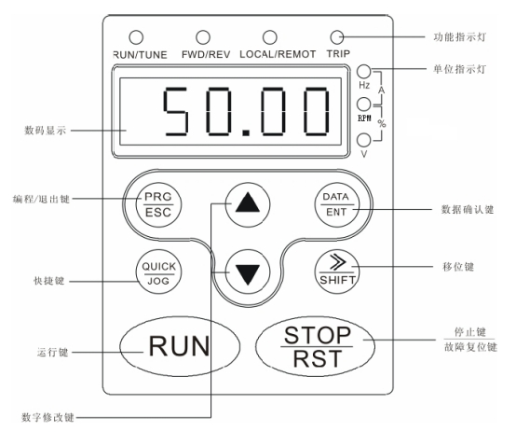
1-1 操作面板示意图

功能指示灯：Function Indicator Light
单位指示灯：Unit Indicator Light
数据显示：Data Display
数据确认键：Confirm Key
编程/退出键：Programming/Exit Key
移位键：Shift Key
快捷键：Shortcut Key
运行键： Run Key
数字修改键：Increment/Decrement Key
停止键/故障复位键：Stop Key/Reset Key

2.1.2 按键功能说明 Key Function
按键符号 | 名称 | 功能说明
 | 编程键 | 一级菜单进入或退出
 | 确定键 | 逐级进入菜单画面、设定参数确认
 | UP递增键 | 数据或功能码的递增
 | DOWN递减键 | 数据或功能码的递减
+ | 组合 | 在停机显示界面和运行显示界面下，可左移循环选择显示参数，注意操作时需先按住DATA/ENT键，然后再按QUICK/JOG键
 | 右移位键 | 在停机显示界面和运行显示界面下，可右移循环选择显示参数；在修改参数时，可以选择参数的修改位
 | 运行键 | 在键盘操作方式下，用于运行操作
 | 停止/  复位键 | 运行状态时，按此键可用于停止运行操作；该功能码P7.04制约。故障报警状态时，所有控制模式都可用该键来复位操作
 | 快捷  多功能键 | 该键功能由功能码P7.03确定  0：寸动运行，为点动键  1：正转反转切换，为正反转切换键  2：清除UP/DOWN设定，清除由UP/DOWN设定的频率值  3：快速调试模式1（按固定菜单调试）  4：快速调试模式2（按最近顺序调试）  5：快速调试模式3（按非出厂值参数调试）
+ | 组合 | RUN键和STOP/RST同时被按下，变频器自由停机

Key | Name | Function
 | Programming | Enter or exit Level I menu.
 | Confirm | Enter the menu interfaces level by level, and confirm the parameter setting.
 | Increment | Increase data or function code.
 | Decrement | Decrease data or function code.
+ | Confirm +quick enter | Select the displayed parameters to left in turn in the stop or running state. When operating, first keep pressing DATA/ENT, then press QUICK/JOG
 | Shift | Select the displayed parameters to the right in turn in the stop or running state, and select the digit to be modified when modifying parameters.
 | Run | Start to work in the operation panel control mode.
 | Stop/Reset | Stop working when it is in the running state and perform the reset operation when it is in the fault state. The functions of this key are restricted in P7.04
 | Quick enter | The functions of this key are set in P7.03  0：“JOG” key  1：Switch between corotation and contrarotation，  2：Clear frequency value set by UP/DOWN  3：Quick enter mode 1（fixed menu）  4：Quick enter mode 2（recent sequence）  5：Quick enter mode 3（non factory set parameter）
+ | RUN/STOP | When RUN and STOP/RST are pressed together, inverter can be stopped freely.

2.2.1 参数设置
三级菜单分别为：
1、功能码组号（一级菜单）；
2、功能码标号（二级菜单）；
3、功能码设定值（三级菜单）。
说明：在三级菜单操作时，可按PRG/ESC键或DATA/ENT键返回二级菜单。两者的区别是：按DATA/ENT键将设定参数存入控制板，然后再返回二级菜单，并自动转移到下一个功能码；按 PRG/ESC键则直接返回二级菜单，不存储参数，并保持停留在当前功能码。举例：将功能码P1.01 从00.00Hz 更改设定为01.05Hz的示例。
1.21．Set parameter
The three-level menu consists of function code group (LevelⅠ), function code (LevelⅡ), and function code setting value (Level Ⅲ).
U can return to Level Ⅱ menu from Level Ⅲ by pressing PRG or ENTER. The difference is that, after u press ENTER, the system saves the parameter setting first, and then goes back to Level Ⅱ menu and shifts to the next function code automatically. After u press PRG, the systems does not save the parameter setting, but directly returns to Level Ⅱ menu and remains at the current function code.
Here is an example of changing the value of P1.01 from 00.00Hz to 01.05Hz.
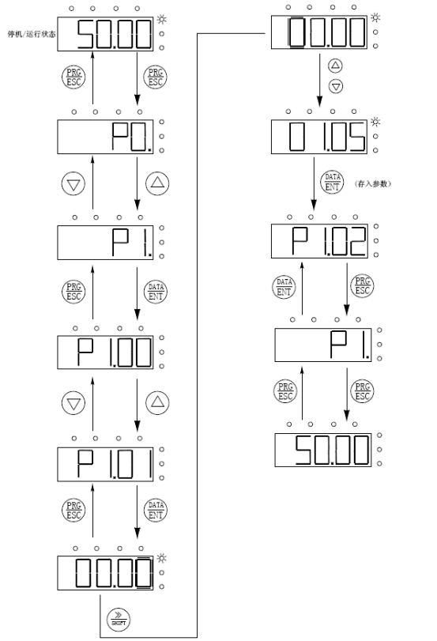
图5-2 三级菜单操作流程图 Level Ⅲ menu operation flowchart
在三级菜单状态下，若参数没有闪烁位，表示该功能码不能修改，可能原因有：
1）该功能码为不可修改参数。如实际检测参数、运行记录参数等；
2）该功能码在运行状态下不可修改，需停机后才能进行修改；
In Level Ⅲ menu, if the parameter has no blinking digit, it means that the parameter cannot be modified. This may be because:
1). Such a function code is only readable, such as actually detected parameter and running record parameter.
2). Such a function code cannot be modified in the running state and can only be changed at stop.

接线 Wire connection
警告
- 为了保证变频器的安全运行，必须由经过认证合格的专业电气人员进行作业。
- 禁止用高压绝缘测试设备测试与变频器连接的电缆的绝缘。
- 即使变频器不处于运行状态，其电源输入线、直流回路端子和电动机端子上仍然可能带有危险电压。因此，断开开关以后还必须等待5分钟，保证变频器放电完毕，再开始作业。
- 必须将变频器的接地端子可靠接地
200V等级接地电阻为100Ω或更小
400V等级接地电阻为10Ω或更小
660V等级接地电阻为5Ω或更小
否则有触电和火灾的危险。
- 不要将变频器的输入端子（R、S、T）和输出端子（U、V、W）接线接错，否则会导致变频器内部损坏。
- 禁止用潮湿的手对变频器进行接线和操作，否则有触电的危险。

当心
- 核实变频器的额定电压是否和AC电源电压相一致
- 电源线和电机线必须永久性紧固连接
注意：控制端子需用软线，否则容易损坏接线端子。
WARNING
- Repair or maintenance may be performed only by qualified personnel. Failure to comply will result in electric shock.
- High-voltage insulation test equipment is forbidden to test insulation performance of cable connected to inverter.
- Even inverter stops running, dangerous voltage may still exists in input power wire, DC circuit terminal and motor terminal. Thus, when power is off, we need wait another five minutes until inverter discharge to begin operation again.
- Make sure ground terminal of inverter connect to earth.
When voltage is 200v, grounding resistance should be no more than 100Ω.
When voltage is 400v, grounding resistance should be no more than 10Ω.
When voltage is 660v, grounding resistance should be no more than 5Ω.
Or else electric shock or fire can be caused.
- Make sure input terminals (R, S, T) and output terminals (U, V, W) are properly connected. Failure to comply will result in damage to inverter.
- Wet hands are not allowed to operate or else it will result in electric shock.
WARNING
- Check whether rated voltage of inverter is consistent with voltage of AC power.
- Make sure power wire and motor are connected tightly.
Flexible wire is preferred or connecting terminal will be easily broken.

2.1 外围设备的连接图 Connection diagram of peripheral devices

2.2 接线端子图photo for connection terminal

2.2.1 主回路端子：primary circuit terminal
(+) | PB | R | S | T | U | V | W | 
(+) | PB | POWER |  |  | MOTOR
图4-2 主回路接线端子图photo for primary circuit terminal (1.5～２.2kW)

(+) | PB | (-) | R | S | T | U | V | W
(+) | PB | (-) | POWER |  |  | MOTOR
图4-3 photo for primary circuit terminal主回路接线端子图(4～5.5kW)

 | (+) | PB | (-) | R | S | T | U | V | W
 |  |  |  | POWER |  |  | MOTOR
图4-4 主回路接线端子图photo for primary circuit terminal (7.5～15kW)

 | R | S | T | P1 | (+) | (-) | U | V | W
 | POWER |  |  | P1 | (+) | (-) | MOTOR
图4-5 主回路接线端子图photo for primary circuit terminal (18.5～110kW)

主回路端子的功能说明如下：Function illustration for primary circuit terminal：
端子名称 | 功能说明
R、S、T | 三相电源输入端子 (单相220V 为R、S)
（+）、（-） | 外接制动单元预留端子
（+）、PB | 外接制动电阻预留端子
P1、（+） | 外接直流电抗器预留端子
（-） | 直流负母线输出端子
U、V、W | 三相交流输出端子
 | 接地端子（PE）

2.2.2 控制回路的端子terminal for control circuit
485+ | 485- | +10V | S1 | S2 | S3 | S4 | HDI |  | RO1A | RO1A
AI1 | AI2 | GND | AO | COM | HDO | PW | +24V |  | RO1B | RO1C
图4-8 1.5～2.2kW 控制回路接线端子图Photo. For terminal for control circuit of4-8

485+ | 485- | +10V | S1 | S2 | S3 | S4 | HDI |  | RO1A | RO1B | RO1C
AI1 | AI2 | GND | AO | COM | HDO | PW | +24V |  | RO2A | RO2B | RO2C
图4-9 10kW及以上控制回路接线端子图
Photo for terminal for control circuit of 4-9 10kW and bigger

控制板端子说明Illustration for control terminal
端子名称 | 端子用途及说明
S1～S4 | 开关量输入端子，与PW和COM形成光耦隔离输入  输入电压范围：9～30V  输入阻抗：3.3kΩ
PW | 外部电源，用户可直接对其接入电源（与COM之间），也可用本机提供的+24V电源，MD320变频器出厂时，默认+24V与PW短接。当使用外部电源时，请与＋24V断开。
+24V | 为本机提供的正24V电源。（电流：150mA）
COM | 为+24V的公共端。
AI1 | 模拟量输入，电压范围：0～10V  输入阻抗：10KΩ
+10V | 为本机提供的正10V电源。
GND | 为正10V的参考零电位。(注意：GND与COM是隔离的)
AO | 模拟量输出端子，可通过跳线J15选择电压或电流输出。  输出范围：电压（0～10V）/电流（0～20mA）
RO1A、RO1B、RO1C | RO1继电器输出，RO1A公共端，RO1B常闭，RO1C常开  触点容量：AC250V/3A，DC30V/1A
Terminal name | illustration and usage for control terminal
S1～S4 | Switch input ，PW and COM optocoupler insulation input  Range of input voltage：9～30V  Input resistance：3.3kΩ
PW | External power supply ，users can connect power supply directly （together with COM ），also can use this machine as +24V power ， factory get +24V and PW short circuit for inverter MD320，if users use external power supply ,pls cut off ＋24V
+24V | this machine can be as power +24V。（current：150mA）
COM | Common terminal for +24V
AI1 | Analog input，range of voltage：0～10V  Input resistance：10KΩ
+10V | External power supply +10V。
GND | consulting zero potential for +10V。(Note：GND and COM is insulated )
AO | analog data input terminal，can choose voltage and current output thru jumper J15  Output range：voltage（0～10V）/current（0～20mA）
RO1A、RO1B、RO1C | RO1 relay output，RO1A common terminal，RO1B normal closed ，RO1C normal open  Contact capacity：AC250V/3A，DC30V/1A

太阳能泵的参数设置
功能码 | 名称 | 参数详细说明 | 缺省值 | 更改 | 序号
P0.03 | A频率指令选择 | 0：键盘设定  1：模拟量AI1设定  2：模拟量AI2设定  3：高速脉冲HDI设定  4：简易PLC程序设定  5：多段速运行设定  6：PID控制设定  7：远程通讯设定  8：面板电位器设定 | 6 | ◎
P0.09 | 最大频率 | 50.00Hz～400.00Hz | 240.00Hz | ◎
P0.11 | 上限频率 | 下限频率P0.13～最大频率P0.09 | 240.00Hz | ○
P0.16 | 加速时间1 | 0.0s～6500.0s | 30.0s | ○
P0.17 | 减速时间1 | 0.0s～6500.0s | 10.0s | ○
P0.18 | 行业参数 | 0：本机参数  1：工厂测试参数  2：轴承端面超参数  3: 木工机械  4: 龙腾自动化  5: 太阳能水泵  6～8： | 5
P3.12 | 频率范围选择 | 0：0～100HZ  1：0～400HZ | 1
P4.00 | S1端子功能选择 | 0： 无功能  1： 正转运行  2： 反转运行  3： 三线式运行控制  4： 正转寸动  5： 反转寸动  6： 自由停车  7： 故障复位  8： 运行暂停  9： 外部故障输入  10：频率设定递增（UP）  11：频率设定递减（DOWN）  12：频率增减设定清除  13：A设定与B设定切换  14：（A+B）设定与A设定切换  15：（A+B）设定与B设定切换  16：多段速端子1  17：多段速端子2  18：多段速端子3  19：多段速端子4  20：多段速暂停  21：加减速时间选择1  22：加减速时间选择2  23：简易PLC停机复位  24：简易PLC频率复位  25：PID控制暂停  26：摆频暂停（停在当前频率）  27：摆频复位（回到中心频率）  28：计数器复位  29：长度复位  30：加减速禁止  31：计数器触发输入  32：计数器触发输入启动  33：频率增减设定暂时清除  34：长度计数输入  35：长度计数复位  36：水位上限停机  37：水位下限开机  38: 缺水保护 | 36
P4.01 | S2端子功能选择 |  | 37
P4.02 | S3端子功能选择 |  | 38
P4.03 | S4端子功能选择
P4.04 | S5端子功能选择
P4.05 | S6端子功能选择
P9.00 | PID给定源 | 0：键盘设定  1：模拟量AI1设定  2：模拟量AI2设定  3：高速脉冲HDI设定  4：多段速运行设定  5：远程通讯设定  6：面板电位器设定  7：太阳能最低有效电压设定Pd.03  8：目标压力设定Pd.04 | 7 | ○
P9.02 | PID反馈源 | 0：模拟量AI1  1：模拟量AI2  2：高速脉冲HDI  3：AI1+AI2  4：AI1-AI2  5：远程通讯设定  6：太阳能输入电压采样值  7：压力传感器值(0～5V; 模拟量AI1) | 6 | ○
P9.03 | PID输出特性选择 | 0：PID输出为正特性  1：PID输出为负特性 | 1 | ○
P9.05 | 比例增益（Kp） | 0.00～100.00 | 50.00 | ○
P9.08 | 采样周期（T） | 0.01～100.00s | 0.01s | ○
Pd.03 | 太阳能最低有效电压 |  | 530 | ○
补充说明：
1.当客户用太阳能模式时不能和压力模式同时使用。上水位S1和GND；下水位S2和GND，井下S3和GND。
2.当客户改用交流电时须把P0.03中的“6”改为“8”；
3.客户可以调节加减速时间；最大频率和上限频率只能比出厂时小不能随意调大负责容易损毁电机和控制器。
4.其他参数无厂家技术指导严禁更改。
Data set for solar power pump
CODE | NAME | ILLUSTRATION | DEFAULT VALUES | ALTER | No.
P0.03 | A frequency instruct choice | 0：key board set  1：analog data AI1 set  2：analog data AI2 set  3：high speed impulse HDI set  4：simple PLC procedure set  5：Multi speed running set  6：PID control set  7：remote communication set  8： panel potentiometer set | 6 | ◎
P0.09 | Max. frequency | 50.00Hz～400.00Hz | 240.00Hz | ◎
P0.11 | Up limit frequency | Lowest frequency P0.13～Max frequency P0.09 | 240.00Hz | ○
P0.16 | Speed up time 1 | 0.0s～6500.0s | 30.0s | ○
P0.17 | Speed down time 1 | 0.0s～6500.0s | 10.0s | ○
P0.18 | Trade data | 0：native data  1：factory testing data  2：bearing end data  3: civil engineering mechanics  4: dragon automatic  5: solar pump  6～8： | 5
P3.12 | Frequency range choice | 0：0～100HZ  1：0～400HZ | 1
P4.00 | S1 terminal function choice | 0： no function  1： running clockwise  2： running anticlockwise  3： three line running model  4： inch forward clockwise  5：inch forward anticlockwise  6： stop free  7： fault reset  8： running pause  9： fault coming out  10：frequency up progressively set（UP）  11：frequency down progressively set（DOWN）  12：frequency change progressively delete  13：change-over from A to B  14：（A+B）set change from A to B  15：（A+B）set change from B to A  16：Multi speed terminal 1  17：Multi speed terminal 2  18：Multi speed terminal 3  19：Multi speed terminal 4  20：Multi speed pause  21：speed change choice 1  22：speed change choice 2  23：sample PLC stop reset  24：sample PLC frequency reset  25：PID stop control  26：swing frequency stop（keep constant frequency）  27：swing frequency reset（back to center frequency）  28：arithmometer reset  29：length reset  30：speed change stop  31：arithmometer detonate input  32:arithmometer detonate input start  33：stop frequency change temporally  34：length counting input  35：length counting reset  36：up water level stop  37：down water level start  38: protect lack of water | 36
P4.01 | S2 terminal function choice |  | 37
P4.02 | S3 terminal function choice |  | 38
P4.03 | S4 terminal function choice
P4.04 | S5 terminal function choice
P4.05 | S6 terminal function choice
P9.00 | PID given source | 0：key board set  1：analog data AI1 set  2：analog data AI2 set  3：high speed impulse HDI set  4：Multi speed running set  5：remote communication set  6：panel potentiometer set  7：effective lowest solar voltage Pd.03  8：target pressure set Pd.04 | 7 | ○
P9.02 | PID feed back source | 0：analog data AI1  1：analog data AI2  2：high speed impulse HDI  3：AI1+AI2  4：AI1-AI2  5：remote communication set  6：input solar voltage sampling value  7：pressure sensor date(0～5V; analog data AI1) | 6 | ○
P9.03 | PID output characteristic choice | 0：PID output as positive characteristic  1：PID output as nagative characteristic | 1 | ○
P9.05 | proportional gain（Kp） | 0.00～100.00 | 50.00 | ○
P9.08 | Sampling period （T） | 0.01～100.00s | 0.01s | ○
Pd.03 | Lowest solar effective voltage |  | 530 | ○
Additional remarks：
1.users can not use it as pressure model and solar model at the same time。Up water level is S1 and GND；down water level is S2 and GND，water level for well is S3 and GND。
2.if users use AC power supply , should change the No.6 to 8 in P0.03；it would be constant pressure working model when PD.04 is same as PD.05
3.users can adjust the time of speed up and down；but can not set the Max. frequency or up frequency higher than the data which set by factory, otherwise, it will get damage.
4.users is forbidden to change other data without factory’s instruction .

故障的诊断和操作对策
故障代码 | 故障类型 | 可能原因 | 简单操作 | 对策 | 序号
E-01 | 输出短路 | 1：查看电机是否短路  2：查看电线是否破损  3：减速过快 | P0.17 | 1：更换电机  2：更换电机  3：增加加速时间
E-02 | 加速过电流 | 加速过快  变频器功率偏小 | P0.16 | 增大加速时间  增加变频器功率
E-03 | 减速过电流 | 减速过快  变频器功率偏小 | P0.17 | 增大减速时间  增加变频器功率
E-04 | 恒速过电流 | 电机负载突然变大 |  | 检查电机负载是否异常
E-05  E-06 | 加速过电压  减速过电压 | 输入电压过高  减速太快 | 万用表拨到750V量输出电压  P0.17 | 检查输入电压  增大减速时间
E-07 | 恒速过电压 | 保护电压设置太小 | Pd.11 | 增大保护电压
E-08 | 母线欠压 | 输入电压过低 | 万用表拨到750V量输出电压 | 检查输入电压
E-09 | 电机过载 | 电机负载突然变大 |  | 检查电机负载是否异常
E-10 | 变频器过载 | 变频器偏小 |  | 增加变频器功率
E-11 | 输入缺相 | 输入电压缺相 | 万用表拨到750V量输出电压是否平衡 | 检查输入电压
E-12 | 输出缺相 | 输出电压或电机缺相 | 万用表拨到750V量输出电压是否平衡或拨打200欧姆量电阻是否平衡 | 输出电压或电机缺相
E-13  E-14 | 整流模块过热  逆变模块过热 | 风道堵塞或风扇损坏  环境温度过高  控制板连线或插件松动 |  | 疏通风道或更换风  降低环境温度  检查并重新连接

FAULT AND SOLUTION
FAULT CODE | FAULT FIELD | FAULT REASON | HANDLE | SOLUTION | SERIESS
E-01 | Output short circuit | 1：check motor coil  2：check power cable  3：speed down too fast | P0.17 | 1：replace motor  2：replace motor  3：prolong the time
E-02 | Speed up overcurrent | Speed up too fast  Controller too small | P0.16 | prolong the time  Change a bigger controller
E-03 | Speed down overcurrent | Speed down too fast  Controller too small | P0.17 | prolong the time  Change a bigger controller
E-04 | Constant speed overcurrent | Overload suddenly |  | Check load
E-05  E-06 | Speed up overvoltage  Speed down overvoltage | Input voltage is too high  Speed down too fast | Check the input voltage  P0.17 | Check the input voltage  prolong the time
E-07 | Constant speed overvoltage | Protecting voltage set too low | Pd.11 | Set protecting voltage higher
E-08 | Power supply under voltage | Input voltage too low | Check the input voltage | Check the input voltage
E-09 | overload | Overload suddenly |  | Check load
E-10 | Controller overload | Controller too small |  | Change a bigger controller
E-11 | Input lacking phase | Input voltage lacking phase | Measure input voltage | Check input voltage
E-12 | Output lacking phase | Input voltage or motor lacking phase | Measure the input voltage or check the resistance of motor coil | Input voltage or motor lacking phase
E-13  E-14 | Rectifier module overheat  inverter module overheat | vent block up or fan get broken  Temperature is too high  Cable connection or plug on controller panel get loose |  | Unclog vent or replace the fan  Lower the temperature  Check and reconnection

三，技术规格与参数Technical specifications and parameters
低压小功率太阳能泵系列,控制器外置Low Voltage Small Power Solar Pump Series, Controller External

型号/MODEL | 输入  功率 IMPUT POWER  W | 电压  V | 太阳能功率 SOLAR POWER  W | 扬程 HEAD  额定/最高  RATED/MAX  M | 流量FLOW  额定/最高  RATED/MAX  T/h | 高度  HEIGHT  M | 重量  KG | 出口 OUTLET  mm | 包装PACKING  mm
3SSW1.8-16-24-120 | 120 | DC24V | 180 | 9/16 | 0.5/18 | 480 | 4.6 | 25 | 120*120*520
3SSW2-22-24-180 | 180 | DC24V | 240 | 15/22 | 0.8/20 | 480 | 4.6 | 25 | 120*120*520
3SSW1.8-16-48-120 | 120 | DC48V | 180 | 9//16 | 0.5/18 | 480 | 4.6 | 25 | 120*120*520
3SSW2-18-48-150 | 150 | DC48V | 225 | 13/18 | 0.7/20 | 480 | 4.9 | 25 | 120*120*520
3SSW2.5-30-48-200 | 200 | DC48V | 300 | 20/30 | 0.7/25 | 480 | 4.6 | 25 | 120*120*520
3SSW2.6-40-48-400 | 400 | DC48V | 600 | 30/40 | 1/2.6 | 510 | 4.9 | 25 | 120*120*600
3SSW2.7-52-48-550 | 600 | DC48V | 750 | 40/52 | 1/2.7 | 540 | 5.3 | 25 | 120*120*600
3SSW3-63-48-600 | 600 | DC48V | 900 | 48/63 | 1/3.0 | 540 | 5.3 | 25 | 120*120*600
3SSW3-78-48-750 | 750 | DC48V | 1125 | 60/78 | 1/3.0 | 580 | 5.3 | 25 | 120*120*600
3SSW3-22-48-300 | 300 | DC48V | 450 | 16//22 | 2/3.0 | 480 | 5.3 | 25 | 120*120*500
3SSW4-33-48-550 | 550 | DC48V | 825 | 22/33 | 2/4.0 | 500 | 5.3 | 25 | 120*120*600
3SSW5-40-48-750 | 750 | DC48V | 1125 | 33/40 | 2/5.0 | 500 | 5.8 | 25 | 150*150*600
3SSW3-120-72-1100 | 1100 | DC72V | 1650 | 45/120 | 1/3 | 680 | 6.0 | 25 | 120*120*700
3SSW5-70-72-1100 | 1100 | DC72V | 1650 | 50/70 | 3/5 | 580 | 5.8 | 25 | 120*120*600
3SSW5-80-96-1300 | 1300 | DC96V | 2000 | 63/80 | 3/5 | 580 | 5.8 | 25 | 120*120*600

3 寸井泵3INCH PUMP

型 号/MODEL | 流量/FLOW  额定/最大  RATED/MAX | 扬程/HEAD  额定/最高  RATED/MAX | 输入功率  IMPUT POWER  KW | 太阳能功率 SOLAR POWER  KW | 电压  V | 转速  r/min | 高度 HEIGHT  mm | 重量  N.W.  Kg | 出口OUTLET  mm | 泵外径 DIA.  mm | 包装PACKING  mm
3SZW2-50-0.75 | 2/5 | 50/70 | 1.0 | 1.5 | 220V | 6000 | 500 | 5.5 | 32 | 75 | 120*120*520
3SZW2-65-1.1 | 2/5 | 65/80 | 1.4 | 2.1 | 220V | 6000 | 540 | 5.8 | 32 | 75 | 120*120*600
3SZW3-50-1.1 | 3/5 | 50/80 | 1.4 | 2.1 | 220V | 6000 | 540 | 5.8 | 32 | 75 | 120*120*600
3SZW2-100-1.5 | 2/6 | 100/120 | 1.88 | 2.8 | 220V | 6000 | 580 | 6.3 | 32 | 75 | 120*120*600
3SZW3-80-1.5 | 3/6 | 80/120 | 1.88 | 2.8 | 220V | 6000 | 460 | 6.3 | 32 | 75 | 120*120*520
4 寸井泵4 INCH PUMP

型 号/MODEL | 流量/FLOW  额定/最大  RATED/MAX | 扬程/HEAD  额定/最高  RATED/MAX | 输入功率  IMPUT POWER  KW | 太阳能功率 SOLAR POWER  KW | 电压  V | 转速  r/min | 高度 HEIGHT  mm | 重量  N.W.  Kg | 出口OUTLET  mm | 包装PACKING  mm
4SZW8-20-0.75 | 8/12 | 20/25 | 0.9 | 1.35 | 220V | 4200 | 550 | 9.4 |  | 150*150*600
4SZW8-26-1.1 | 8/13 | 26/36 | 1.38 | 2.07 | 220V | 5000 | 550 | 9.4 | 38 | 150*150*600
4SZW2-70-1.1 | 2/7 | 70/85 | 1.4 | 2.1 | 220V | 5000 | 620 | 10.1 | 38 | 150*150*700
4SZW3-50-1.1 | 3/8 | 50/65 | 1.4 | 2.1 | 220V | 5000 | 600 | 9.9 | 38 | 150*150*700
4SZW4-40-1.1 | 4/6.6 | 40/48 | 1.3 | 1.95 | 220V | 5000 | 570 | 9.6 | 38 | 150*150*600
4SZW10-18-1.1 | 10/20 | 18/22 | 1.29 | 1.93 | 220V | 4000 | 550 | 9.5 | 38 | 150*150*600
4SZW2-100-1.5 | 2/7 | 100/115 | 1.85 | 2.78 | 220V | 5000 | 710 | 10.7 | 38 | 150*150*800
4SZW5-50-1.5 | 5/10 | 50/85 | 1.85 | 2.78 | 220V | 5000 | 600 | 10.1 | 38 | 150*150*700
4SZW6-45-1.5 | 6/12 | 45/65 | 1.85 | 2.78 | 220V | 5200 | 570 | 9.8 | 38 | 150*150*600
4SZW10-30-1.5 | 10/14 | 30/44 | 1.8 | 2.7 | 220V | 5000 | 580 | 9.8 | 38 | 150*150*600
4SZW13-22-1.5 | 13/23 | 22/28 | 1.85 | 2.78 | 220V | 5000 | 540 | 9.6 | 50 | 150*150*600
4SZW10-37-1.8 | 10/14 | 37/52 | 2.35 | 3.53 | 220V | 5000 | 570 | 9.8 | 38 | 150*150*600
4SZW10-45-2.2 | 10/14 | 45/60 | 2.85 | 4.27 | 220/380V | 4800 | 665 | 11.1 | 38 | 150*150*700
4SZW3-130-2.2 | 3/8 | 130/150 | 3.6 | 5.4 | 220/380V | 5000 | 790 | 12.5 | 38 | 150*150*800
4SZW2-180-2.2 | 2/7 | 180/195 | 3.7 | 5.5 | 220/380V | 5000 | 930 | 13.5 | 38 | 150*150*1000
4SZW8-60-2.2 | 8/12 | 60/85 | 2.89 | 4.33 | 220/380V | 5000 | 690 | 11.3 | 38 | 150*150*700
4SZW16-25-2.2 | 16/26 | 25/35 | 2.63 | 3.95 | 220/380V | 5000 | 605 | 11.1 | 50 | 150*150*700
4SZW10-58-3 | 10/14 | 58/74 | 4.0 | 6 | 220/380V | 5000 | 685 | 12.0 | 38 | 150*150*700
4SZW3-175-3 | 3/5 | 175/198 | 3.85 | 5.78 | 220/380V | 5000 | 885 | 14.0 | 38 | 150*150*900
4SZW5-100-3 | 5/8 | 100/120 | 3.57 | 5.3 | 220/380V | 5000 | 740 | 12.7 | 38 | 150*150*800
4SZW10-50-3 | 10/14 | 50/65 | 3.57 | 5.3 | 220/380V | 5000 | 660 | 11.8 | 38 | 150*150*700
4SZW18-30-3 | 18/29 | 30/42 | 3.31 | 5 | 220/380V | 4600 | 650 | 11.5 | 50 | 150*150*700
4SZW6-120-4 | 6/8 | 120/142 | 5.1 | 7.65 | 380V | 5000 | 770 | 13.7 | 38 | 150*150*800
4SZW10-80-4 | 10/14 | 80/110 | 5.2 | 7.8 | 380V | 5000 | 735 | 13.3 | 38 | 150*150*800
4SZW4-160-4 | 4/6 | 160/185 | 5.2 | 7.8 | 380V | 5000 | 860 | 14.4 | 50 | 150*150*900
4SSZW20-45-4 | 20/32 | 45/57 | 5.31 | 7.96 | 380V | 5200 | 685 | 13.1 | 50 | 150*150*700
4SZW5-200-5.5 | 5/8 | 200/267 | 7.2 | 10.8 | 380V | 5000 | 970 | 16.2 | 38 | 150*150*1000
4SZW6-150-5.5 | 6/8 | 150/178 | 6.5 | 9.75 | 380V | 5000 | 890 | 14.8 | 38 | 150*150*900
4SZW10-120-5.5 | 10/14 | 120/148 | 7.3 | 11 | 380V | 5000 | 860 | 14.9 | 38 | 150*150*900
4SZW20-55-5.5 | 20/30 | 55/75 | 6.9 | 10.35 | 380V | 5000 | 725 | 14.3 | 50 | 150*150*8000
4SZW10-150-7.5 | 10/18 | 150/210 | 8.8 | 13.2 | 380V | 5000 | 970 | 18.9 | 38 | 150*150*1000
4SZW20-80-7.5 | 20/28 | 80/90 | 9.1 | 13.6 | 380V | 5000 | 815 | 18.2 | 50 | 150*150*900
4SZW5-240-7.5 | 5/8 | 240/300 | 9.1 | 13.6 | 380V | 5000 | 1070 | 19.7 | 38 | 150*150*1100

6 寸井泵6 INCH PUMP

型 号/MODEL | 流量/FLOW  额定/最大  RATED/MAX | 扬程/HEAD  额定/最高  RATED/MAX | 输入功率  IMPUT POWER  KW | 太阳能功率 SOLAR POWER  KW | 电压  V | 转速  r/min | 高度 HEIGHT  mm | 重量  N.W.  Kg | 出口OUTLET  mm | 包装PACKING  mm
6SZW17-25-1.8 | 17/50 | 25/26.5 | 2.16 | 3.24 | 220/380V | 4000 | 850 | 37.7 | 75 | 200*200*890
6SZW25-20-2.2 | 25/46 | 20/23 | 2.94 | 4.41 | 220/380V | 4000 | 850 | 37.7 | 75 | 200*200*890
6SZW30-22-3 | 30/51 | 22/27 | 3.96 | 5.94 | 220/380V | 4000 | 850 | 37.7 | 75 | 200*200*890
6SZW25-25-3 | 25/45 | 25/32 | 3.72 | 5.58 | 220/380V | 4000 | 850 | 37.7 | 75 | 200*200*890
6SZW50-18-4 | 50/76 | 18/26 | 4.8 | 7.2 | 380V | 4000 | 930 | 39.7 | 100 | 200*200*960
6SZW45-25-5.5 | 40/65 | 25/55 | 6.7 | 10 | 380V | 4000 | 930 | 39.7 | 75 | 200*200*960
6SZW25-50-5.5 | 25/45 | 50/80 | 6.7 | 10 | 380V | 4000 | 855 | 38.9 | 75 | 200*200*890
6SZW70-22-7.5 | 70/103 | 22/39 | 8.75 | 13.1 | 380V | 4000 | 1150 | 65.5 | 100 | 200*200*1180
6SZW20-110-11 | 20/40 | 110/146 | 13 | 19.5 | 380V | 4000 | 990 | 42.5 | 75 | 200*200*1020
6SZW50-45-11 | 50/70 | 45/82 | 12.9 | 19.3 | 380V | 4000 | 1000 | 42.5 | 75 | 200*200*1030
6SZW25-130-15 | 25/40 | 130/200 | 17.6 | 26.4 | 380V | 4000 | 1035 | 43.7 | 75 | 200*200*1080
6SZW25-150-18.5 | 25/40 | 150/200 | 21.8 | 32.7 | 380V | 4000 | 945 | 45 | 75 | 200*200*975
6SZW50-90-22 | 50/70 | 90/134 | 29.8 | 44.7 | 380V | 4000 | 1210 | 48 | 100 | 200*200*1240
6SZW25-180-22 | 25/40 | 180/226 | 29.8 | 44.7 | 380V | 4000 | 1135 | 46.3 | 75 | 200*200*1170
6SZW25-250-30 | 25/45 | 250/296 | 35 | 52.3 | 380V | 4000 | 1275 | 48.4 | 75 | 200*200*1300
6SZW40-150-30 | 40/70 | 150/193 | 35 | 52.3 | 380V | 4000 | 1340 | 49.5 | 75 | 200*200*1400
6SZW25-300-37 | 25/40 | 300/385 | 43 | 51.9 | 380V | 4000 | 1365 | 52 | 75 | 200*200*1400
8 寸井泵8 INCH PUMP

型 号/MODEL | 流量/FLOW  额定/最大  RATED/MAX | 扬程/HEAD  额定/最高  RATED/MAX | 输入功率  KW | 电压  V | 转速  r/min | 高度HEIGHT  mm | 重量  N.W.  Kg | 出口OUTLET  mm | 包装 PACKING  mm
8SZW100-32-13 | 100/136 | 32/49 | 15.3 | 380V | 4000 | 890 | 39/6 | 100 | 290*290*1000
8SZW100-40-15 | 100/140 | 40/50 | 17.3 | 380V | 4000 | 890 | 39/6 | 100 | 292*290*1000
8SZW130-30-18.5 | 130/162 | 30/49 | 20.8 | 380V | 4000 | 900 | 39/6 | 100 | 290*292*1000
8SZW50-100-22 | 50/69 | 100/140 | 25.3 | 380V | 4000 | 920 | 45.5/6 | 100 | 290*290*1000
8SZW130-35-22 | 130/165 | 35/55 | 25.3 | 380V | 4000 | 920 | 43/6 | 100 | 292*290*1000
8SZW100-65-30 | 70/95 | 100/140 | 35.7 | 380V | 4000 | 1040 | 47/6 | 100 | 290*292*1100
8SZW30-180-30 | 30/40 | 180/220 | 35.7 | 380V | 4000 | 1300 | 70 | 75 | 290*292*1400
8SZW100-85-37 | 100/136 | 85/120 | 42.7 | 380V | 4000 | 1120 | 78 | 100 | 290*290*1200
8SZW130-70-45 | 130/165 | 70/95 | 51.5 | 380V | 4000 | 970 | 60 | 100 | 292*290*1100
8SZW130-100-55 | 130/160 | 100/135 | 62.4 | 380V | 4000 | 1120 | 65 | 100 | 290*292*1200

四，泵使用须知：Notice for Using Pump
4.1．泵全扬程工作，入水深度可达5 0米。使用前，应检查电泵是否完好无损，各连接处有无松动及渗、 漏油现象，电缆线等有无碰压划破等意外损伤，并用兆欧表测量电泵绝缘电阻，冷态时应≥50MΩ．热态≥2MΩ。
4.2．泵对电源要求是±10%，控制器输出稳定，电压过低时，输出电流会增大，会到达保护电流的高置值使控制器因保护而不工作，这时要改用手动工作状态，将泵转速调低一点即可。
4.3．是泵应单独配置相应的电闸或开关， 泵外壳上接地端子要接地线，电泵引出线中有黄绿相间的双色线为接地线，必须可靠接地。（整条有修改）
电泵配带的电缆线长度不够需加接时，加接的电线线径必须大于原电线线径。接头处要用防水胶布密封好。 ”
4.4．电泵正式使用前先接上电源检查启动、运转是否正常，泵工作方向是逆时针，注意短时间转一下，在无水严禁运转的，检查电泵转向是否正确。三相电泵如转向不对，调接电源输入线中任意二根线即可。
4.5．安装吊放电泵时，应在孔环处串绳进行，严禁提拉电缆线吊放电泵，但离水底应在1米以上，以防泥沙吸入，损坏机械密封和叶轮等部件。
4.6．电泵工作时，要特别注意水位下降情况，尤其是在井下工作时，千万不能使电泵露出水面工作或脱水，运行，否则会烧坏电机和其它部件。也不能放到水底污泥中工作，造成散热不好而损坏泵电机。
4.1. If pump is working on its rated head, then pump can be displaced 50 meter under the water. Before working, please check that whether the pump is good condition, no loose connection, no seepage and leakage of oil and no damage of cable. Use the ohmmeter to measure insulation electric resistance of pump. When the pump is in cold conditions, the electric resistance can be ≥50MΩ, and when the pump is in hot conditions, the electric resistance can be ≥2MΩ.
4.2. The pump power requirement is ±10%. When the controller output power is constant and the voltage is too low, the output current will increase and reach the upper limit of the controller for protection so that the controller will stop working. At this time we should change the pump to manual working mode and slow down the speed a bit.
4.3. The pump should be equipped with its unique electric brake and switch separately. Ground terminals on the pump housing should be connected to the ground wire. Wires in green and yellow colors are ground wires and should be connected the ground accordingly.
When the cables equipped on the electric pump are not long enough and should be lengthened, the diameter of the lengthened cable must be larger than the previous one. Use waterproof adhesive tape to seal the joint.
4.4．Before using, connect the pump to power supply and check whether it’s starting and running are normal. Please note that pump should work in counterclockwise direction. Keep the pump working in short time to check whether the rotation direction of the electric pump is correct，pump is forbids running without water. If the rotation direction of the three-phase electric pump is not correct, then adjust any two of the power input lines.
4.5．The installing and hoisting of electric pump should be performed at the
annular ring by the lifting rope．It is forbidden to lift the cable to hoist the electric pump. pump should be placed more than 1 m away from the bottom so as to prevent the suction of sediment and avoid the damage of components such as machine ring and impellers．
4.6．Pay attention to the water level when the electric pump is working, especially when it is working under the well．Never keep the electric pump work emerging the water level or without water, otherwise the motor and other components may be damaged. Also the pump can’t work under sludge or the motor will be damaged because of poor heat dissipation.

五，维护与保养
1．电泵累计运行3 0 0 0小时后，必须更换易损件一次(如轴承、密封圈、机械密封等)，否则机件损坏后会造成更大的损失
2．电泵如长时间不用，则应清洗擦干，视表面漆皮脱落情况，放置通风干燥处妥善保管．Maintenance
1．It is a must to replace vulnerable parts(such as bearing．seal ring，
mechanical seal etc．）once the electric pump has run 3000 hours
accumulatively so as to avoid greater loss resulting from the damage of machine parts.
2．It is recommended to wash and wipe the electric pump for long time nonuse and then place it to a ventilated and dry place for keeping properly according to the actual peeling condition of the surface paint coat．

故障现象 | 原因 | 解决办法
电机不转 | - 电源或控制器接线不对  - 控制器处于故障保护状态  - 泵叶轮卡位，电机不起动  - 泵电机损坏  - 控制器故障 | - 检查线路  - 检查电路及控制器，消除故障  - 检查泵卡位原因，消除故障  - 控制器、泵电机、轴承、线圈等部件如有故障请和维修服务部门联系
泵不出水或水量不足 | - 叶轮转向不对  - 进水口滤网或叶轮堵塞  - 叶轮磨损严重  - 电机线圈一组或部分损坏 | - 调换泵输入的电线  - 消除堵塞杂物  - 更换叶轮送维修部
PROBLEM | CAUSE | SOLUTION
Motor cannot run | - Power cable connect with controller wrongly  - Controller is in the fault protection state  - Pump impeller is blocked and motor cannot start  - Pump motor damaged  - Controller damaged | - Check the cable connection  - Check all connection and set the controller all over again  - Check the pump body ,make sure impeller can turn freely  - Please contact repair and service agent when you have no idea with the fault
No water out or water flow is small | - Motor run reversely  - Pump inlet strainer is blocked  - Impellers wear seriously  - Winding coil burned | - Exchange the input cable  - Remove the jam  - Replace the impeller  - Replace motor

